**BỘ GIÁO DỤC VÀ ĐÀO TẠO**

**ĐẠI HỌC SƯ PHẠM THÀNH PHỐ HỒ CHÍ MINH**

**KHOA CÔNG NGHỆ THÔNG TIN**

🙚🙚🙚🕮🙘🙘🙘

**LẬP TRÌNH NÂNG CAO**

**BÀI TẬP QUÁ TRÌNH 01**

Họ và tên : Phạm Nguyệt Anh

MSSV: 46.01.104.005

**Giảng viên: Nguyễn Thị Ngọc Hoa**

Thành phố Hồ Chí Minh, ngày 14 tháng 3 năm 2023

**MỤC LỤC**

CHƯƠNG 1: QUÁ TẢI TOÁN TỬ 4

1. Cơ bản 4

1.1. COMPLEX_NUMBER 4

1.2. DATHUC3 6

1.3. SODAO 11

1.4. SOMOI 13

1.5. HCN 15

1.6. PHANSO5 17

1.7. DATHUC2 18

1.8. DATE 21

1.9. DTRON 31

1.11. SOCHANLE 39

1.12. XUATDIEM 42

1.13. PSOHONSO 45

1.14. TGIAC 49

1.15. DATHUC 53

1.16. PhanSo2 56

1.17. QTaiMang2 59

1.18. QtaiMang 61

1.19. QtaiPSo 64

2. Trung bình 66

2.1. COLORED_POINT 66

2.2. Operator01 66

2.3. DAOHAM 66

CHƯƠNG 2: KHUÔNG HÌNH (TEMPLATE) 70

2. Cơ bản 70

2.1. TEMPLATESOMOI 70

2.2. TEMPLATEHCN 73

2.3. TEMP_M1C 76

2.4. TEMPLATE1 77

2.5. KhuonHinhTong 81

2.7. Template2 87

2.8. KhuonHinhSS 90

2.9. Template1 91

CHƯƠNG 3: CON TRỎ 94

3.1. 1718_2_LTNC_Midterm_01 94

3.2. CONTRO1 97

3.3. CONTRO2 98

3.4. CONTRO3 101

3.5. CONTRO5 103

3.6. Josephus 105

3.7. Pointer_Array_01 107

3.8. Pointer_Mang_2 109

3.9. Pointer_MissingPrime 110

CHƯƠNG 4: VECTOR 112

4.1. xoa_vector 112

4.2. VECTOR3 113

4.3. Vector 114

4.4. Vector2 117

4.5. Vector1 118

CHƯƠNG 5: NHẬP XUẤT FILE 120

5.1. ONTAP 120

5.2. FSTREAM1 127

5.3. fstream3 128

5.4. fstream2 129

5.5. fstream1 130

CHƯƠNG 6: STRING (CHUỖI) 131

6.1. Capitalize 131

6.2. CHUSOTANCUNG 132

6.3. DAONGUOC 133

6.4. DAONGUOC1 134

6.5. DAONGUOC2 135

6.6. DAONGUOC3 136

6.7. DEMCHUOI 137

6.8. DOIXUNG 139

6.9. DATE 140

6.10. DAYNP 148

6.11. SoPalindrom 151

6.12. HAPPYNEWYEAR 152

6.13. Hpalindrome 154

6.14. NUMCOUNT 155

6.15. MINIGAME19.2HOTEN 156

6.16. MINIGAME18.2TACHSO 157

6.17. LOGIN_UP 159

6.18. LOGIN_UP2 160

6.19. STRINGPBRK 161

6.20. XOACHUOI 163

6.21. 1718_2_LTNC_Midterm_02 165

CHƯƠNG 7: STACK VÀ QUEUE 166

7.1. PALINDROME_STRING 166

7.2. TRUNGHAUTO2 167

7.3. TRUNGHAUTO1 169

7.4. QUEUE1 171

7.5. TT_HT1 173

7.6. DOICS10_2 174

7.7. HAUTO 175

7.8. STACK1 177

7.9. NGOACDUNG 178

CHƯƠNG 1: QUÁ TẢI TOÁN TỬ

1. Cơ bản
   1. COMPLEX_NUMBER

Số có dạng z = a + bi, trong đó a, b là số thực, i2= -1, gọi là **số phức**. Trong đó a gọi là phần thực (real), còn b gọi là phần ảo (image).

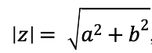, gọi là mô-đun của số phức z

Cho hai số phức z1 = a + bi, z2 = c + di

Cộng, trừ số phức:

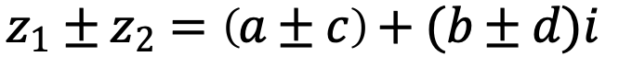

Xây dựng cấu trúc mô tả một dãy N (0 <= N <= 10,000) số phức với các thao tác sau:

a)     Tính tổng N số phức

b)    Tính hiệu N số phức

c)     Tính mô-đun N số phức

d)    Xuất N số phức theo định dạng: z = a + bi (với a là phần thực và b là phần ảo)

***Yêu cầu****: sử dụng kĩ thuật cấp phát động và con trỏ để quản lý dãy số. Bài làm không đúng yêu cầu sẽ không được tính điểm.*

Input:

-       N dòng, mỗi dòng là 1 cặp a và b mô tả thông tin phần thực và phần ảo của 1 số phức.

Output:

-       Dòng 1: xuất N số phức theo định dạng {a+bi}, mỗi số phức cách nhau 1 khoảng trắng;

-       Dòng 2: giá trị mô-đun của N số phức, lấy tối đa 2 số lẻ ở phần thập phân, mỗi giá trị cách nhau 1 khoảng trắng;

-       Dòng 3: xuất tổng N số phức

#include <iostream>

#include <math.h>

#include <iomanip>

using namespace std;

struct SoPhuc {

int real;

int image;

void operator = (SoPhuc a) {

real = a.real;

image = a.image;

}

SoPhuc() {

real = image = 0;

}

};

struct Mang {

SoPhuc a[1000];

int n;

SoPhuc& operator[](int i) {

return a[i];

}

};

// So phuc

istream& operator>>(istream& is, SoPhuc& sp) {

is >> sp.real >> sp.image;

return is;

}

ostream& operator<<(ostream& os, SoPhuc sp) {

os << "{" << sp.real << (sp.image > 0 ? "+" : "") << sp.image << "i}" << " ";

return os;

}

//nhap xuat mang

istream& operator>>(istream& is, Mang& m) {

m.n = 0;

while (is >> m.a[m.n++]) {}

m.n--;

return is;

}

ostream& operator<<(ostream& os, Mang m) {

for (int i = 0; i < m.n; i++) {

os << m.a[i];

}

return os;

}

float Module(SoPhuc a) {

float kq;

kq = float(sqrt(pow(a.real, 2) + pow(a.image, 2)));

return kq;

}

SoPhuc operator+(SoPhuc a, SoPhuc b) {

SoPhuc kq;

kq.real = a.real + b.real;

kq.image = a.image + b.image;

return kq;

}

int main()

{

Mang a;

cin >> a;

cout << a << endl;

for (int i = 0; i < a.n; i++) {

cout << fixed << setprecision(2) << Module(a[i]) << " ";

}

cout << endl;

SoPhuc tong;

for (int i = 0; i < a.n; i++) {

tong = tong + a[i];

}

cout << tong;

return 0;

}

* 1. DATHUC3

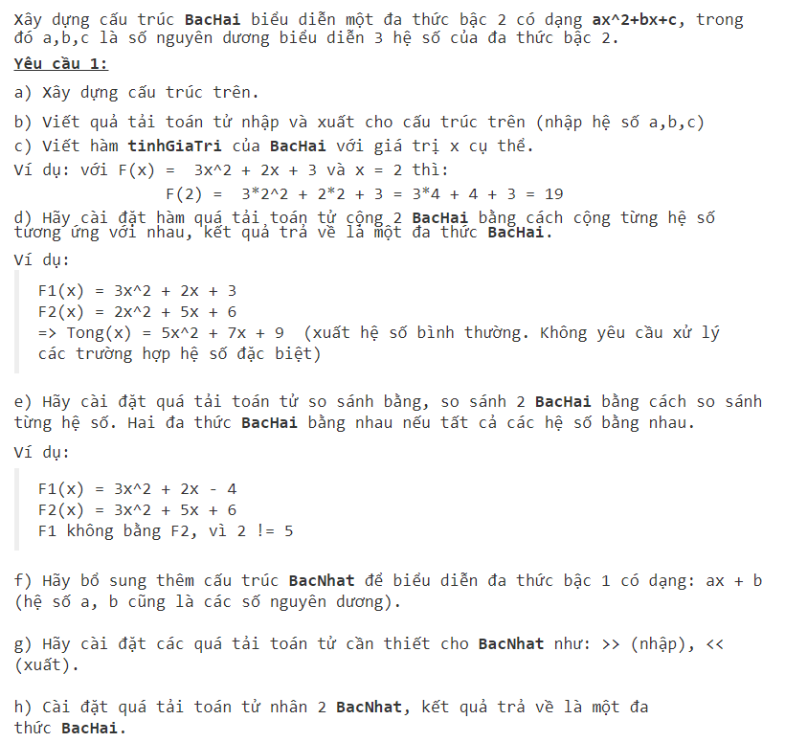

#include <iostream>

#include <iomanip>

#include <math.h>

using namespace std;

int x =0;

struct bacHai {

int a, b, c;

};

struct bacNhat {

int a, b;

};

istream& operator>>(istream& is, bacHai& bh) {

is >> bh.a >> bh.b >> bh.c;

return is;

}

ostream& operator << (ostream & os, bacHai bh) {

os << bh.a << "x^2";

if (bh.b >= 0) cout << "+"; else "";

os << bh.b << "x";

if (bh.c >= 0) cout << "+"; else "";

os << bh.c << endl;

return os;

}

// bac nhat

istream& operator>>(istream& is, bacNhat& bn) {

is >> bn.a >> bn.b;

return is;

}

ostream& operator << (ostream& os, bacNhat bn) {

os << bn.a << "x";

if (bn.b >= 0) cout << "+"; else "";

os << bn.b;

return os;

}

int tinhGiaTri_BacHai(bacHai bh) {

return (bh.a * x * x + bh.b * x + bh.c);

}

bacHai operator+(bacHai h1, bacHai h2) {

bacHai kq;

kq.a = h1.a + h2.a;

kq.b = h1.b + h2.b;

kq.c = h1.c + h2.c;

return kq;

}

bacHai operator*(bacNhat h1, bacNhat h2) {

bacHai kq;

kq.a = h1.a * h2.a;

kq.b = h1.a * h2.b + h1.b * h2.a;

kq.c = h1.b * h2.b;

return kq;

}

bool operator==(bacHai h1,bacHai h2) {

return (h1.a == h2.a && h1.b == h2.b && h1.c == h2.c);

}

int main()

{

bacHai h1, h2;

bacNhat h3, h4;

cin >> h1 >> h2 >> h3 >> h4;

cin >> x;

cout << h1;

cout << tinhGiaTri_BacHai(h1) << endl;

cout << h2;

cout << tinhGiaTri_BacHai(h2) << endl;

cout << h1 + h2;

cout << tinhGiaTri_BacHai(h1 + h2)<< endl;

bacHai h5 = h3 * h4;

cout << "(" << h3 << ") * (" << h4 << ")" << " = " << h5;

cout << tinhGiaTri_BacHai(h5) << endl;

if (h1 == h2 && h2 == h5) {

cout << "TRUE3";

return 0;

}

if (h1 == h5) {

cout << "TRUE1"; return 0;

}

if (h2 == (h3 * h4)) {

cout << "TRUE2"; return 0;

}

cout << "FALSE";

return 0;

}

* 1. SODAO

#include <iostream>

using namespace std;

struct SoDao {

int a;

void operator=(SoDao sd) {

a = sd.a;

}

};

istream& operator>>(istream& is, SoDao& sd) {

is >> sd.a;

return is;

}

ostream& operator << (ostream& os, SoDao sd) {

os << "[SoDao]" << sd.a << endl;

return os;

}

int DaoSo(SoDao sd) {

int tmp;

int dao = 0 ;

while (sd.a > 0) {

tmp = sd.a % 10;

dao = (dao * 10) + tmp;

sd.a = sd.a / 10;

}

return dao;

}

bool operator>(SoDao sd1, SoDao sd2) {

return (DaoSo(sd1) > DaoSo(sd2));

}

SoDao operator+(SoDao sd1, SoDao sd2) {

SoDao kq;

kq = sd1 + sd2;

return kq;

}

int tong(SoDao sd1, SoDao sd2) {

return DaoSo(sd1) + DaoSo(sd2);

}

int main()

{

SoDao a, b;

cin >> a >> b;

cout << a << b;

if (a > b) {

cout << "YES" << endl;

}

else

cout << "NO" << endl;

cout << DaoSo(a) + DaoSo(b);

return 0;

}

* 1. SOMOI

#include <iostream>

#include <math.h>

using namespace std;

struct SoMoi {

int A;

void operator = (SoMoi sm) {

A = sm.A;

}

};

istream& operator >> (istream& is, SoMoi& sm) {

is >> sm.A;

return is;

}

ostream& operator << (ostream& os, SoMoi sm) {

os << "[SoMoi] " << sm.A << endl;

return os;

}

int tongChuSo(SoMoi sm) {

int dem = 1;

while (sm.A >= 10) {

sm.A /= 10;

dem++;

}

return dem;

}

int tinhTong(SoMoi sm1) {

int tong = 0;

while (sm1.A > 0) {

tong += sm1.A % 10;

sm1.A /= 10;

}

return tong;

}

bool operator> (SoMoi a, SoMoi b) {

return tinhTong(a) > tinhTong(b);

}

SoMoi operator+ (SoMoi sm1, SoMoi sm2) {

SoMoi sm3;

sm3.A = tinhTong(sm1) + tinhTong(sm2);

return sm3;

}

int main()

{

SoMoi a, b;

cin >> a >> b;

cout << a << b;

if (a > b) {

cout << "true" << endl;

}

else

cout << "false" << endl;

cout << a + b;

return 0;

}

* 1. HCN

#include <iostream>

using namespace std;

struct HCN {

int a, b;

};

istream & operator >> (istream &is, HCN &hcn);

ostream & operator << (ostream &os, HCN hcn);

float ChuVi(HCN hcn);

bool operator < (HCN hcn1, HCN hcn2);

float operator + (HCN hcn, float x);

ostream & operator << (ostream &os, HCN hcn){

os << "[HCN]" << hcn.a << "," << hcn.b;

return os;

}

istream & operator >> (istream &is, HCN &hcn){

is >> hcn.a >> hcn.b;

return is;

}

float ChuVi(HCN hcn){

return (hcn.a + hcn.b) * 2;

}

bool operator < (HCN hcn1, HCN hcn2){

return ChuVi(hcn1) < ChuVi(hcn2);

}

float operator + (HCN hcn, float x){

return ChuVi(hcn) + x;

}

int main(){

HCN h1, h2;

cin >> h1;

cin >> h2;

cout << h1 << endl;

cout << h2 << endl;

if (h1 <h2){

cout << "true";

}

else cout << "false";

return 0;

}

* 1. PHANSO5

#include <iostream>

using namespace std;

struct PhanSo {

int tu, mau;

};

istream& operator >> (istream& is, PhanSo& a) {

is >> a.tu >> a.mau;

return is;

}

ostream& operator << (ostream& os, PhanSo a) {

os << a.tu << "/" << a.mau;

return os;

}

PhanSo operator++ (PhanSo a) {

a.tu += 1;

return a;

}

PhanSo operator-- (PhanSo a) {

a.tu -= 1;

return a;

}

int main()

{

PhanSo a;

string b;

cin >> a;

cin >> b;

cout << a << endl;

if (b == "++") {

cout << ++a;

}else

if (b == "--") {

cout << --a;

}

}

* 1. DATHUC2

#include <iostream>

#include <math.h>

using namespace std;

int x;

struct BacNhat {

int a, b;

int& operator= (BacNhat x) {

x.a = a;

x.b = b;

}

};

int tinhCong(BacNhat h1) {

return (h1.a * x + h1.b);

}

istream& operator >> (istream& is, BacNhat& bn) {

is >> bn.a >> bn.b;

return is;

}

ostream& operator << (ostream& os, BacNhat bn) {

os << bn.a << "x+" << bn.b;

return os;

}

BacNhat operator+ (BacNhat h1, BacNhat h2) {

BacNhat kq;

kq.a = h1.a + h2.a;

kq.b = h1.b + h2.b;

return kq;

}

bool operator == (BacNhat h1, BacNhat h2) {

if (h1.a + h1.b == h2.a + h2.b)

return true;

return false;

}

int main()

{

BacNhat h1, h2;

cin >> h1 >> h2 >> x;

cout << h1 << "\n" << h2 << endl;

cout << h1 << "+" << h2 << "=" << h1 + h2 << endl;

cout << tinhCong(h1)<< endl;

cout << tinhCong(h2) << endl;

if (h1 == h2)

cout << "TRUE";

else

cout << "FALSE";

return 0;

}

* 1. DATE

#include <iostream>

#include <string>

using namespace std;

struct Date

{

int month, day, year;

};

istream& operator>>(istream& inp, Date& d)

{

inp >> d.day >> d.month >> d.year;

return inp;

}

ostream& operator<<(ostream& out, Date d)

{

if (d.day < 10) out << 0 << d.day;

else out << d.day;

out << "/";

if (d.month < 10) out << 0 << d.month;

else out << d.month;

out << "/";

out << d.year;

return out;

}

bool LeapYear(Date d)

{

return (d.year % 4 == 0 && d.year % 100 != 0) || (d.year % 400 == 0);

}

int ndayofYear(Date d)

{

int x = 0, i;

for (i = 1; i < d.month; i++)

{

switch (i)

{

case 1: case 3: case 5: case 7: case 8: case 10: case 12:

{

x += 31;

break;

}

case 4: case 6: case 9: case 11:

{

x += 30;

break;

}

case 2:

{

if (LeapYear(d))

{

x += 29;

}

else

{

x += 28;

}

break;

}

}

}

return x + d.day;

}

string ndayofWeek(Date d)

{

string s;

int n = d.year;

int c = ndayofYear(d);

int t1 = (n - 1) / 4;

int t2 = (n - 1) / 100;

int t3 = (n - 1) / 400;

int k = (n - 1) + t1 - t2 + t3 + c;

switch (k % 7)

{

case 0:

{

s = "Sunday";

break;

}

case 1:

{

s = "Monday";

break;

}

case 2:

{

s = "Tuesday";

break;

}

case 3:

{

s = "Wednesday";

break;

}

case 4:

{

s = "Thursday";

break;

}

case 5:

{

s = "Friday";

break;

}

case 6:

{

s = "Saturday";

break;

}

}

return s;

}

int ndayofMonth(Date d)

{

int nday;

switch (d.month)

{

case 1: case 3: case 5: case 7: case 8: case 10: case 12:

{

nday = 31;

break;

}

case 4: case 6: case 9: case 11:

{

nday = 30;

break;

}

case 2:

{

if (LeapYear(d))

{

nday = 29;

}

else

{

nday = 28;

}

break;

}

}

return nday;

}

Date nextDay(Date d)

{

Date nextd;

if (d.day == ndayofMonth(d))

{

if (d.month == 12)

{

nextd.day = 1;

nextd.month = 1;

nextd.year = d.year + 1;

}

else

{

nextd.day = 1;

nextd.month = d.month + 1;

nextd.year = d.year;

}

}

else

{

nextd.day = d.day + 1;

nextd.month = d.month;

nextd.year = d.year;

}

return nextd;

}

bool operator==(Date d1, Date d2)

{

return d1.day == d2.day && d1.month == d2.month && d1.year == d2.year;

}

void likendayofWeek(Date d1, Date d2)

{

ndayofWeek(d1) == ndayofWeek(d2) ? cout << "TRUE" : cout << "FALSE";

}

bool operator<(Date d1, Date d2)

{

if (d1.year < d2.year)

{

return true;

}

else if (d1.year == d2.year)

{

if (d1.month < d2.month)

{

return true;

}

else if (d1.month == d2.month)

{

if (d1.day < d2.day) return true;

else return false;

}

else return false;

}

else return false;

}

int operator-(Date d1, Date d2)

{

int y;

if (d1.year == d2.year)

{

if (d1 < d2)

{

return ndayofYear(d2) - ndayofYear(d1);

}

else if (d1 == d2) return 0;

else

{

return ndayofYear(d1) - ndayofYear(d2);

}

}

if (d1.year < d2.year)

{

if (LeapYear(d1))

{

y = 366 - ndayofYear(d1);

}

else y = 365 - ndayofYear(d1);

for (int i = d1.year + 1; i < d2.year; i++)

{

if ((i % 4 == 0 && i % 100 != 0) || (i % 400 == 0))

{

y += 366;

}

else y += 365;

}

return y + ndayofYear(d2);

}

if (d1.year > d2.year)

{

if (LeapYear(d2))

{

y = 366 - ndayofYear(d2);

}

else y = 365 - ndayofYear(d2);

for (int i = d2.year + 1; i < d1.year; i++)

{

if ((i % 4 == 0 && i % 100 != 0) || (i % 400 == 0))

{

y += 366;

}

else y += 365;

}

return y + ndayofYear(d1);

}

}

int main()

{

Date x1, x2;

cin >> x1;

cin >> x2;

cout << x1 << " " << ndayofWeek(x1) << " " << ndayofYear(x1) << " " << nextDay(x1) << " ";

LeapYear(x1) == true ? cout << "TRUE" : cout << "FALSE";

cout << endl;

cout << x2 << " " << ndayofWeek(x2) << " " << ndayofYear(x2) << " " << nextDay(x2) << " ";

LeapYear(x2) == true ? cout << "TRUE" : cout << "FALSE";

cout << endl;

likendayofWeek(x1, x2);

cout << endl;

if (x1 < x2) cout << "1 < 2";

else if (x1 == x2) cout << "1 = 2";

else cout << "1 > 2";

cout << endl;

cout << x1 - x2;

}

* 1. DTRON

#include <bits/stdc++.h>

using namespace std;

struct Diem {

int td, hd;

};

struct DTRON {

Diem o;

double r;

};

// diem

istream& operator>>(istream& is, Diem& d) {

is >> d.td >> d.hd;

return is;

}

ostream& operator << (ostream& os, Diem d) {

os << "(" << d.td << "," << d.hd << ")";

return os;

}

// duong tron

istream& operator>>(istream& is, DTRON& dt) {

is >> dt.o >> dt.r;

return is;

}

ostream& operator << (ostream& os, DTRON dt) {

os << dt.o << " " << dt.r << endl;

return os;

}

double tinhCV(DTRON dt) {

return (2 * 3.14 * dt.r);

}

bool operator==(DTRON dt1, DTRON dt2) {

return tinhCV(dt1) == tinhCV(dt2);

}

bool operator<(DTRON dt1, DTRON dt2) {

return tinhCV(dt1) < tinhCV(dt2);

}

double tinhDT(DTRON dt) {

return 3.14 * dt.r * dt.r;

}

double operator+(DTRON dt1, DTRON dt2) {

return tinhDT(dt1) + tinhDT(dt2);

}

//quá tải toán tử trừ ( - ) để tính khoảng cách giữa 2 điểm

Diem operator-(Diem a, Diem b) {

Diem d;

d.td = a.td - b.td;

d.hd = a.hd - b.hd;

return d;

}

double tinhKC(Diem a, Diem b) {

double d;

d = sqrt(pow((b.td - a.td), 2) + pow((b.hd - a.hd), 2));

return d;

}

//Viết quá tải so sánh bằng ( == ) để kiểm tra 2 điểm trùng nhau

bool operator==(Diem a, Diem b) {

return (a.td == b.td && a.hd == b.hd);

}

void VTTD(DTRON dt1, DTRON dt2) {

double d2;

d2 = tinhKC(dt1.o, dt2.o);

if (d2 > abs(dt1.r - dt2.r) && d2 < dt1.r + dt2.r) {

cout << "C" << endl; // cat nhau

}

if (d2 == abs(dt1.r - dt2.r)) {

cout << "TXT" << endl; // tiep xuc trong

}

if (d2 == (dt1.r + dt2.r)) {

cout << "TXN" << endl;

}

if (d2 > (dt1.r + dt2.r)) {

cout << "NN" << endl;

}

if (d2 < abs(dt1.r - dt2.r) && d2 != 0) {

cout << "DN" << endl;

}

if (d2 == 0) {

cout << "DT" << endl; // dong tam

}

}

int main()

{

DTRON dt1, dt2;

cin >> dt1 >> dt2;

cout << dt1 << dt2;

double dt3 = tinhDT(dt1) + tinhDT(dt2);

cout << roundf(dt3 * 1000) / 1000 << endl;

if (tinhCV(dt1) == tinhCV(dt2)) {

cout << "1 = 2" << endl;

}

if (tinhCV(dt1) < tinhCV(dt2)) {

cout << "1 < 2" << endl;

}

if (tinhCV(dt2) < tinhCV(dt1)) {

cout << "1 > 2" << endl;

}

VTTD(dt1, dt2);

return 0;

}

* 1. DTHANG

#include <bits/stdc++.h>

using namespace std;

struct DTHANG {

double a, b, c;

DTHANG() {

a = b = c = 0;

}

};

// duong thang

istream& operator>>(istream& is, DTHANG& dt) {

is >> dt.a >> dt.b >> dt.c;

return is;

}

ostream& operator << (ostream& os, DTHANG dt) {

// a

if (dt.a == 0) {

os << "";

}

else if (dt.a == 1) {

os << "x";

}

else os << dt.a << "x";

// b

if (dt.b == 0) {

os << "";

}else if (dt.b == 1) {

os << (dt.a == 0 ? "": "+") << "y";

}

else if (dt.b > 1) {

os << (dt.a == 0 ? "" : "+") << dt.b << "y";

}

else {

os << (dt.a == 0 ? "" : "") << dt.b << "y";

}

// c

if (dt.c == 0) {

os << "=0" << endl;

}

else if (dt.c > 0) {

os << "+" << dt.c << "=0" << endl;

}

else {

os << "" << dt.c << "=0" << endl;

}

return os;

}

bool operator == (DTHANG d1, DTHANG d2) {

return d1.a == d2.a && d1.b == d2.b && d1.c == d2.c;

}

char VTTD(DTHANG d1, DTHANG d2) {

int D = d1.a * d2.b - d2.a * d1.b;

int Dx = d2.c * d1.b - d1.c * d2.b;

int Dy = d2.a * d1.c - d1.a * d2.c;

if (D == 0) {

if (Dx == Dy && Dx == 0) {

return 'T';

}

else if (Dx != 0 || Dy != 0) {

return 'S';

}

}

if (d1.a * d2.a + d1.b * d2.b == 0) {

return 'V';

}

return 'C';

}

int UCLN(int a, int b) {

if (a < 0)

a = -a;

if (b < 0)

b = -b;

if (a % b == 0)

return b;

return UCLN(b, a % b);

}

int main()

{

DTHANG d1, d2;

cin >> d1 >> d2;

cout << d1 << d2;

cout << VTTD(d1, d2) << endl;

int D = d1.a * d2.b - d2.a * d1.b;

int Dx = d2.c * d1.b - d1.c * d2.b;

int Dy = d2.a * d1.c - d1.a * d2.c;

if (VTTD(d1, d2) == 'C'|| VTTD(d1,d2) == 'V') {

if (Dx % D == 0) {

cout << "(" << Dx / D << ",";

}

else if ((Dx < 0 && D < 0) || (Dx > 0 && D < 0)) {

cout << "(" << -Dx / UCLN(Dx, D) << "/" << -D / UCLN(Dx, D) << ",";

}

else {

cout << "(" << Dx / UCLN(Dx, D) << "/" << D / UCLN(Dx, D) << ",";

}

if (Dy % D == 0) {

cout << Dy / D << ")";

}

else if ((Dy < 0 && D < 0) || (Dy > 0 && D < 0)) {

cout << -Dy / UCLN(Dy, D) << "/" << -D / UCLN(Dy, D) << ")";

}

else {

cout << Dy / UCLN(Dy, D) << "/" << D / UCLN(Dy, D) << ")";

}

}

else if (VTTD(d1, d2) == 'S') {

double Sx, Sy;

if (d1.a != 0) {

Sx = double(-d1.c / d1.a);

Sy = 0;

}

else {

Sx = 0;

Sy = double(-d1.c / d1.b);

}

double KC = abs(d2.a * Sx + d2.b * Sy + d2.c) / sqrt((pow(d2.a, 2)) + pow(d2.b, 2));

cout << roundf(KC * 1000) / 1000;

}

else {

cout << "0";

}

return 0;

}

* 1. SOCHANLE

#include <bits/stdc++.h>

using namespace std;

struct SoChanLe {

string a;

};

istream& operator >> (istream& is, SoChanLe& a) {

is >> a.a;

return is;

}

ostream& operator <<(ostream& os, SoChanLe& a) {

for (int i = 0; i < a.a.size(); i += 2) {

os << a.a[i];

}

return os;

}

bool operator< (SoChanLe a, SoChanLe b) {

int A = 0;

int B = 0;

for (int i = 0; i < a.a.size(); i += 2) {

A = A * 10 + (a.a[i] - 48);

}

for (int i = 0; i < b.a.size(); i += 2) {

B = B * 10 + (b.a[i] - 48);

}

return A < B;

}

int tongThanhPhan(SoChanLe a, int type = 0) {

int tong = 0;

if (type == 0) {

for (int i = 0; i < a.a.size(); i+= 2) {

tong += (a.a[i] - 48);

}

}

else {

for (int i = 1; i < a.a.size(); i+= 2) {

tong += (a.a[i] - 48);

}

}

return tong;

}

int main() {

SoChanLe a, b;

int type;

cin >> a >> b >> type;

cout << a << "\n" << b << endl;

if (a < b) {

cout << "true" << endl;

}else

cout << "false" << endl;

cout << tongThanhPhan(a, type) << endl;

cout << tongThanhPhan(b, type) << endl;

return 0;

}

* 1. XUATDIEM

#include <iostream>

using namespace std;

struct Diem {

int x, y;

void operator = (Diem a) {

x = a.x;

y = a.y;

}

Diem() {

x = 0;

y = 0;

}

};

istream& operator >> (istream& is, Diem& d) {

is >> d.x >> d.y;

return is;

}

ostream& operator << (ostream& os, Diem d) {

os << "(" << d.x << "," << d.y << ")" << endl;

return os;

}

bool operator==(Diem d1, Diem d2) {

if (d1.x == d2.x && d1.y == d2.y)

return true;

return false;

}

bool operator< (Diem d1, Diem d2) {

if (d1.x < d2.x) {

return true;

}

else if (d1.x == d2.x) {

if (d1.y < d2.y)

return true;

return false;

}

if (d1.x > d2.x)

return false;

}

Diem operator+ (Diem a, Diem b) {

Diem kq;

kq.x = a.x + b.x;

kq.y = a.y + b.y;

return kq;

}

int main()

{

Diem a[100];

int n = 0;

while (cin >> a[n]) {

n++;

}

Diem max = a[0];

Diem sum;

for (int i = 0; i < n; i++) {

sum = sum + a[i];

if (max < a[i])

max = a[i];

}

cout << max;

cout << sum;

return 0;

}

* 1. PSOHONSO

#include <iostream>

using namespace std;

struct PhanSo {

int tu, mau;

};

struct HonSo {

int hs;

PhanSo ps;

void operator= (HonSo a) {

hs = a.hs;

ps = a.ps;

}

};

istream& operator >> (istream& is, PhanSo& a) {

is >> a.tu >> a.mau;

return is;

}

ostream& operator << (ostream& os, PhanSo a) {

os << a.tu << "/" << a.mau;

return os;

}

bool operator!= (PhanSo a, PhanSo b) {

if (a.tu == b.tu && a.mau == b.mau)

return false;

return true;

}

//HON SO

istream& operator >> (istream& is, HonSo& a) {

is >> a.hs >> a.ps;

return is;

}

ostream& operator << (ostream& os, HonSo a) {

os << a.hs << " " << a.ps;

return os;

}

int ucln(int tu, int mau) {

while (mau > 0) {

int x = tu % mau;

tu = mau;

mau = x;

}

return tu;

}

PhanSo rutGonPS(PhanSo a) {

int x = ucln(a.tu, a.mau);

a.tu /= x;

a.mau /= x;

return a;

}

PhanSo operator+ (PhanSo a, PhanSo b) {

PhanSo kq;

kq.tu = a.tu * b.mau + a.mau * b.tu;

kq.mau = a.mau * a.mau;

return rutGonPS(kq);

}

PhanSo operator- (PhanSo a, PhanSo b) {

PhanSo kq;

kq.tu = a.tu * b.mau - a.mau * b.tu;

kq.mau = a.mau * a.mau;

return rutGonPS(kq);

}

HonSo operator-(HonSo a) { return a; }

HonSo operator+ (HonSo a) {

return a;

}

PhanSo chuyenPS(HonSo a) {

PhanSo kq;

kq.tu = a.hs * a.ps.mau + a.ps.tu;

kq.mau = a.ps.mau;

return rutGonPS(kq);

}

HonSo rutGonHS(HonSo a) {

chuyenPS(a);

int x = a.ps.tu / a.ps.mau;

a.hs += x;

int y = a.ps.tu % a.ps.mau;

a.ps.tu = y;

a.ps = rutGonPS(a.ps);

return a;

}

bool operator!= (HonSo a, HonSo b) {

return !(a.hs == b.hs && a.ps.tu == b.ps.tu && a.ps.mau == b.ps.mau);

}

int tongCacThanhPhan(HonSo a) {

int tong;

tong = a.hs + a.ps.tu + a.ps.mau;

return tong;

}

bool operator > (HonSo a, HonSo b) {

return tongCacThanhPhan(a) > tongCacThanhPhan(b);

}

int main()

{

HonSo a, b;

string c;

cin >> a >> b >> c;

if (a != b) {

cout << "TRUE" << endl;

}

else

cout << "FALSE" << endl;

//

if (a > b) {

cout << "TRUE"<< endl;

}

else

cout << "FALSE" << endl;

//

if (c == "true") {

cout << rutGonHS(a) << "\n" << rutGonHS(b);

}

else if (c == "false")

cout << chuyenPS(a) << "\n" << chuyenPS(b);

return 0;

}

* 1. TGIAC

#include <iostream>

#include <math.h>

#include <cmath>

using namespace std;

struct Diem {

int x, y;

void operator = (Diem a) {

x = a.x;

y = a.y;

}

Diem() {

x = 0;

y = 0;

}

};

istream& operator >> (istream& is, Diem& d) {

is >> d.x >> d.y;

return is;

}

ostream& operator << (ostream& os, Diem d) {

os << "(" << d.x << "," << d.y << ")" << " ";

return os;

}

bool operator==(Diem a, Diem b) {

if (a.x == b.x && a.y == b.y)

return true;

return false;

}

double tinhKhoangCach(Diem a, Diem b) {

int d;

d = sqrt ((b.x - a.x) * (b.x - a.x) + (b.y - a.y) * (b.y - a.y));

return d;

}

struct TamGiac {

Diem a,b,c;

void operator= (TamGiac tg) {

a = tg.a;

b = tg.b;

c = tg.c;

}

};

istream& operator >> (istream& is, TamGiac& d) {

is >> d.a >> d.b >> d.c;

return is;

}

ostream& operator << (ostream& os, TamGiac d) {

os << d.a << d.b << d.c;

return os;

}

double tinhChuViTG(TamGiac tg) {

double P;

double AB = tinhKhoangCach(tg.a, tg.b);

double AC = tinhKhoangCach(tg.a, tg.c);

double BC = tinhKhoangCach(tg.b, tg.c);

P = AB + AC + BC;

return P;

}

/*TamGiac operator+ (TamGiac tg1, TamGiac tg2) {

double P3;

P3 = tinhChuViTG(tg1) + tinhChuViTG(tg2);

return tg1;

}*/

bool operator< (TamGiac a, TamGiac b) {

return tinhChuViTG(a) < tinhChuViTG(b);

}

bool kiemtra(Diem a, Diem b) {

if (a.y == b.y && a.x == b.x)

return true;

return false;

}

bool operator==(TamGiac tg1, TamGiac tg2) {

if (kiemtra(tg1.a, tg2.a) || kiemtra(tg1.a, tg2.b) || kiemtra(tg1.a, tg2.c) &&

kiemtra(tg1.b, tg2.a) || kiemtra(tg1.b, tg2.b) || kiemtra(tg1.b, tg2.c) &&

kiemtra(tg1.c, tg2.a) || kiemtra(tg1.c, tg2.b) || kiemtra(tg1.c, tg2.c))

return true;

return false;

}

int main()

{

TamGiac tg1, tg2;

cin >> tg1 >> tg2;

cout << tg1 << "\n" << tg2 << endl;

if (tg1 < tg2) {

cout << "TRUE" << endl;

}

else {

cout << "FALSE" << endl;

}

if (tg1 == tg2) {

cout << "TRUE" << endl;

}

else

cout << "FALSE";

return 0;

}

* 1. DATHUC

#include <iostream>

#include <math.h>

using namespace std;

int x;

struct BacNhat {

int a, b;

int& operator= (BacNhat x) {

x.a = a;

x.b = b;

}

};

int tinhCong(BacNhat h1) {

return (h1.a * x + h1.b);

}

istream& operator >> (istream& is, BacNhat& bn) {

is >> bn.a >> bn.b;

return is;

}

ostream& operator << (ostream& os, BacNhat bn) {

os << bn.a << "x+" << bn.b;

return os;

}

BacNhat operator+ (BacNhat h1, BacNhat h2) {

BacNhat kq;

kq.a = h1.a + h2.a;

kq.b = h1.b + h2.b;

return kq;

}

bool operator == (BacNhat h1, BacNhat h2) {

if (h1.a + h1.b == h2.a + h2.b)

return true;

return false;

}

int main()

{

BacNhat h1, h2;

cin >> h1 >> h2 >> x;

cout << h1 << "\n" << h2 << endl;

cout << h1 << "+" << h2 << "=" << h1 + h2 << endl;

cout << tinhCong(h1)<< endl;

cout << tinhCong(h2) << endl;

if (h1 == h2)

cout << "TRUE";

else

cout << "FALSE";

return 0;

}

* 1. PhanSo2

#include <iostream>

#include <cmath>

using namespace std;

struct PhanSo {

int tu, mau;

void operator= (PhanSo a) {

tu = a.tu ;

mau = a.mau;

}

PhanSo() {

tu = 0;

mau = 1;

}

};

int ucln(int tu, int mau) {

while (mau > 0) {

int x = tu % mau;

tu = mau;

mau = x;

}

return tu;

}

struct Mang {

PhanSo a[1000];

int n;

PhanSo& operator[] (int i) {

return a[i];

}

};

PhanSo rutGon(PhanSo a){

int x = ucln(a.tu, a.mau);

PhanSo rg;

rg.tu = a.tu /= x;

rg.mau = a.mau /= x;

return rg;

}

istream& operator >> (istream& is, PhanSo& a) {

is >> a.tu >> a.mau;

return is;

}

ostream& operator << (ostream& os, PhanSo a) {

os << a.tu << "/" << a.mau;

return os;

}

istream& operator>> (istream& is, Mang& m) {

m.n = 0;

while (is >> m.a[m.n++]) {}

m.n--;

return is;

}

ostream& operator<< (ostream& os, Mang m) {

for (int i = 0 ; i < m.n ; i++) {

os << m[i] << endl;

}

return os;

}

bool operator== (PhanSo a, PhanSo b){

return a.tu*b.mau == a.mau*b.tu;

}

bool operator!= (PhanSo a, PhanSo b){

return !(a == b);

}

PhanSo operator+ (PhanSo a, PhanSo b) {

PhanSo kq;

kq.tu = a.tu * b.mau + a.mau * b.tu;

kq.mau = a.mau * b.mau;

return rutGon(kq);

}

int main()

{

Mang m;

cin >> m;

PhanSo tong;

for (int i = 0 ; i < m.n ; i++) {

tong = tong + m[i];

}

cout << tong;

return 0;

}

* 1. QTaiMang2

#include <iostream>

using namespace std;

struct M1C {

int t;

int a[50];

int& operator [] (int i) {

return a[i];

}

void operator = (M1C m) {

t = m.t;

for (int i = 0; i < t; i++)

a[i] = m[i];

}

};

istream& operator >> (istream& is, M1C &m);

ostream& operator << (ostream& os, M1C m);

M1C operator +(M1C m1, M1C m2);

int main() {

M1C m1, m2;

cin >> m1 >> m2;

M1C m3;

m3=m1+m2;

cout << m3;

return 0;

}

istream& operator >> (istream& is, M1C &m) {

is >> m.t;

for (int i = 0; i < m.t; i++) {

is >> m[i];

}

return is;

}

ostream& operator << (ostream& os, M1C m) {

for (int i = 0; i < m.t; i++) {

os << m[i] << " ";

}

return os;

}

M1C operator + (M1C m1, M1C m2){

M1C m3;

if (m1.t < m2.t){

m3=m2;

for (int i=0; i < m1.t;i++){

m3[i]=m3[i]+m1[i];

}

}

else {

m3=m1;

for (int i =0;i<m2.t;i++){

m3[i]=m3[i]+m2[i];

}

}

return m3;

}

* 1. QtaiMang

#include <iostream>

#include <math.h>

using namespace std;

struct Mang {

int sl;

int a[100];

int& operator = (Mang m) {

m.sl = sl;

for (int i = 0; i < sl; i++) {

m.a[i] = a[i];

}

}

int operator[] (int i) {

return a[i];

}

};

istream& operator >> (istream& is, Mang& m) {

is >> m.sl;

for (int i = 0; i < m.sl; i++) {

is >> m.a[i];

}

return is;

}

ostream& operator << (ostream& os, Mang m) {

os << m.sl << endl;

for (int i = 0; i < m.sl; i++) {

os << m.a[i] << " ";

}

return os;

}

Mang operator+ (Mang m1, Mang m2) {

Mang kq;

if (m1.sl <= m2.sl) {

kq.sl = m2.sl;

for (int i = 0; i < kq.sl; i++) {

kq.a[i] = m1.a[i] + m2.a[i];

}

cout << kq;

}

else {

kq.sl = m1.sl;

}

return kq;

}

bool operator==(Mang m1, Mang m2) {

if (m1.sl != m2.sl)

return false;

else {

for (int i = 0; i < m1.sl; i++) {

if (m1.a[i] == m2.a[i])

return true;

}

return false;

}

}

bool operator !=(Mang m1, Mang m2) {

return !(m1 == m2);

}

int main() {

Mang m1,m2;

cin >> m1 >> m2;

if (m1 == m2) {

cout << "yes";

}

else

cout << "no" << endl;

return 0;

}

* 1. QtaiPSo

#include <iostream>

#include<cmath>

#include<math.h>

using namespace std;

struct PhanSo {

int tu;

int mau;

};

int ucln(int tu, int mau) {

while (mau > 0) {

int x = tu % mau;

tu = mau;

mau = x;

}

return tu;

}

istream& operator >> (istream& is, PhanSo& a) {

is >> a.tu >> a.mau;

return is;

}

ostream& operator << (ostream& os, PhanSo a) {

os << a.tu << "/" << a.mau;

return os;

}

PhanSo rutGon(PhanSo ps) {

int x = ucln(ps.tu,ps.mau) ;

ps.tu /= x;

ps.mau /= x;

return ps;

}

PhanSo operator+ (PhanSo a, PhanSo b) {

PhanSo kq;

kq.tu = a.tu * b.mau + a.mau * b.tu;

kq.mau = a.mau * b.mau;

return rutGon(kq);

}

bool operator == (PhanSo a, PhanSo b) {

return (a.tu * b.mau == a.mau * b.mau);

}

bool operator != (PhanSo a, PhanSo b) {

return !(a == b);

}

int main()

{

PhanSo a, b;

cin >> a >> b;

cout << a + b << endl;

return 0;

}

1. Trung bình
   1. COLORED_POINT
   2. Operator01
   3. DAOHAM

#include <iostream>

#include <fstream>

using namespace std;

struct DaThuc

{

int n;

int a[100];

DaThuc()

{

n = 0;

a[0]=0;

}

int& operator [](int n)

{

return a[n];

}

};

istream& operator >> (istream& is, DaThuc& p)

{

is >> p.n;

for (int i = p.n; i >= 0; i--)

{

is >> p[i];

}

return is;

}

ostream& operator << (ostream& os, DaThuc p)

{

if (p[p.n] != 0)

{

if (p.n > 1)

{

if (p[p.n] == 1)

os << "x^" << p.n;

else if (p[p.n] == -1)

os << "-x^" << p.n;

else

os << p[p.n] << "x^" << p.n;

}

else if (p.n == 1)

{

if (p[p.n] == 1)

os << "x";

else if (p[p.n] == -1)

os << "-x";

else

os << p[p.n] << "x";

}

else if (p.n == 0)

{

os << p[0];

return os;

}

}

else if(p.n == 0)

os << p[0];

for (int i = p.n - 1; i > 1; i--)

{

if (p[i] > 0)

{

if (p[i] != 1)

os << "+" << p[i] << "x^" << i;

else

os << "+" << "x^" << i;

}

else if (p[i] < 0)

{

if (p[i] != -1)

os << p[i] << "x^" << i;

else

os << "-x^" << i;

}

else

continue;

}

if (p[1] != 0 && p.n >1)

{

if (p[1] > 0)

{

if (p[1] != 1)

os << "+" << p[1] << "x";

else

os << "+" << "x";

}

else if (p[1] < 0)

{

if (p[1] != -1)

os << p[1] << "x";

else

os << "-" << "x";

}

}

if (p[0] != 0)

{

if (p[0] > 0)

os << "+" << p[0];

else if (p[0] < 0)

os << p[0];

}

return os;

}

DaThuc DaoHam(DaThuc p)

{

DaThuc result;

if (p.n > 0)

{

result.n = p.n - 1;

for (int i = result.n; i >= 0; i--)

{

result[i] = p[i + 1] * (i + 1);

}

}

return result;

}

int main()

{

DaThuc test;

cin >> test;

cout << test << endl;

DaThuc DH1 = DaoHam(test);

DaThuc DH2 = DaoHam(DH1);

cout << DH1 << endl;

cout << DH2;

return 0;

}

CHƯƠNG 2: KHUÔNG HÌNH (TEMPLATE)

1. Cơ bản
3. 1. TEMPLATESOMOI

#include <iostream>

using namespace std;

struct SoMoi {

long gt;

};

long tongSoMoi(SoMoi sm);

istream& operator >> (istream& is, SoMoi& sm);

ostream& operator << (ostream& os, SoMoi sm);

bool operator > (SoMoi sm1, SoMoi sm2);

long operator + (SoMoi sm, long n);

template<typename T>

struct Mang {

T q[1000];

int n;

};

template <typename T>

istream& operator >> (istream& is, Mang<T>& m) {

T x; m.n = 0;

while (is >> x) {

m.q[m.n++] = x;

}

return is;

}

template <typename T>

T timMax(Mang<T> m) {

T max = m.q[0];

for (int i = 1; i < m.n; i++) {

if (m.q[i] > max) {

max = m.q[i];

}

}

return max;

}

int main() {

char ch;

cin >> ch;

if (ch == 'N') {

Mang<int> N;

cin >> N;

int max = timMax(N), dem = 0, tong = 0;

cout << max << endl;

for (int i = 0; i < N.n; i++) {

if (N.q[i] == max) {

dem++;

}

tong += N.q[i];

}

cout << dem << endl;

cout << tong;

}

else if (ch == 'M') {

Mang<SoMoi> M;

cin >> M;

SoMoi max = timMax(M);

int dem = 0, tong = 0;

cout << max << endl;

for (int i = 0; i < M.n; i++) {

if (tongSoMoi(M.q[i]) == tongSoMoi(max)) {

dem++;

}

tong = M.q[i] + tong;

}

cout << dem << endl;

cout << "[SoMoi] " << tong;;

}

return 0;

}

long tongSoMoi(SoMoi sm) {

long tong = 0; long x;

while (sm.gt > 0) {

x = sm.gt % 10;

sm.gt /= 10;

tong += x;

}

return tong;

}

istream& operator >> (istream& is, SoMoi& sm) {

is >> sm.gt;

return is;

}

ostream& operator << (ostream& os, SoMoi sm) {

os << "[SoMoi] " << sm.gt;

return os;

}

bool operator > (SoMoi sm1, SoMoi sm2) {

return (tongSoMoi(sm1) > tongSoMoi(sm2));

}

long operator + (SoMoi sm, long n) {

return (tongSoMoi(sm) + n);

}

* 1. TEMPLATEHCN

#include <iostream>

#include <cmath>

#include <algorithm>

#include <string>

#include <stdio.h>

using namespace std;

struct hcn {

float dai, rong;

void operator =(hcn h) {

dai = h.dai;

rong = h.rong;

}

};

istream& operator >> (istream& is, hcn& h) {

is >> h.dai >> h.rong;

return is;

}

ostream& operator << (ostream& os, hcn h) {

os << "[HCN] " << h.dai << "," << h.rong;

return os;

}

float chuvi(hcn h) {

return (h.dai + h.rong) * 2;

}

bool operator < (hcn h1, hcn h2) {

return (chuvi(h1) < chuvi(h2));

}

template <class T>

struct Mang {

T a[100];

int n;

T& operator [] (int i) {

return a[i];

}

};

template <class T>

T TimMin(Mang <T> h) {

T Min = h[0];

for (int i = 0; i < h.n; i++) {

if (h[i] < Min) Min = h[i];

}

return Min;

}

float operator + (hcn h1, float a) {

return (chuvi(h1) + a);

}

int main() {

Mang <int> k;

Mang <hcn> h;

string s;

cin >> s;

if (s == "N") {

k.n = 0;

while (cin >> k[k.n]) {

k.n++;

}

cout << TimMin(k) << endl;

float s1 = 0;

for (int i = 0; i < k.n; i++) {

s1 = s1 + k[i];

}

cout << s1;

}

if (s == "H") {

h.n = 0;

while (cin >> h[h.n]) {

h.n++;

}

cout << TimMin(h) << endl;

float s2 = 0;

for (int i = 0; i < h.n; i++) {

s2 = s2 + chuvi(h[i]);

}

printf("%.1f", s2);

}

return 0;

}

* 1. TEMP_M1C

#include <iostream>

using namespace std;

template <typename Temp>

struct M1C {

int n;

Temp a[100];

void operator= (M1C A) {

n = A.n;

for (int i = 0; i < n; i++) {

a[i] = A[i];

}

}

Temp& operator[] (int i) {

return a[i];

}

M1C() {

n = 0;

}

};

M1C<int> a;

template <typename Temp>

void xuat(M1C<Temp> a) {

for (int i = 0; i < a.n; i++) {

cout << a[i] << " ";

}

}

int tong(M1C<int> a) {

int Tong = a[0];

for (int i = 1; i < a.n; i++) {

Tong = Tong + a[i];

}

return Tong;

}

template <typename Temp>

void xuat() {

cout << tong(a);

}

template <typename Temp>

void nhap(M1C<Temp>& a) {

a.n = 0;

int b;

while (cin >> b) {

a[a.n++] = b;

}

xuat<Temp>();

}

int main() {

nhap<int>(a);

return 0;

}

* 1. TEMPLATE1

#include <bits/stdc++.h>

using namespace std;

class Oxy {

protected:

int x, y;

public:

Oxy(int a = 0, int b = 0) {

x = a;

y = b;

}

Oxy(const Oxy& a) {

x = a.x;

y = a.y;

}

~Oxy() {}

double operator- (Oxy a) {

return sqrt(pow(a.x - x, 2) + pow(a.y - y, 2));

}

bool operator< (Oxy a) {

return x < a.x || (x == a.x && y < a.y);

}

friend istream& operator>> (istream& is, Oxy& a) {

is >> a.x >> a.y;

return is;

}

friend ostream& operator<< (ostream& os, Oxy a) {

os << "(" << a.x << "," << a.y << ")";

return os;

}

};

class Oxyz {

protected:

int x, y, z;

public:

Oxyz(int a = 0, int b = 0, int c = 0) {

x = a;

y = b;

z = c;

}

Oxyz(const Oxyz& a) {

x = a.x;

y = a.y;

z = a.z;

}

~Oxyz() {}

double operator- (Oxyz a) {

return sqrt(pow(a.x - x, 2) + pow(a.y - y, 2) + pow(a.z - z, 2));

}

bool operator< (Oxyz a) {

return x < a.x || (x == a.x && y < a.y) || (x == a.x && y == a.y && z < a.z);

}

friend istream& operator>> (istream& is, Oxyz& a) {

is >> a.x >> a.y >> a.z;

return is;

}

friend ostream& operator<< (ostream& os, Oxyz a) {

os << "(" << a.x << "," << a.y << "," << a.z << ")";

return os;

}

};

template <typename Temp>

bool up(Temp a, Temp b) {

return a < b;

}

template <typename Temp>

bool down(Temp a, Temp b) {

return b < a;

}

template <typename Temp>

class Array {

protected:

int n;

Temp a[1001];

public:

int getn() { return n; }

void setn(int x) { n = x; }

Array() {

n = 0;

}

Temp& operator[] (int i) {

return a[i];

}

void Up() {

sort(a, a + n, up<Temp>);

}

void Down() {

sort(a, a + n, down<Temp>);

}

friend istream& operator>> (istream& is, Array<Temp>& ar) {

is >> ar.n;

for (int i = 0; i < ar.n; i++) {

is >> ar[i];

}

return is;

}

friend ostream& operator<< (ostream& os, Array<Temp> ar) {

for (int i = 0; i < ar.n; i++) {

os << ar[i] << " ";

}

return os;

}

double maxOfTwo() {

double temp = 0;

for (int i = 0; i < n; i++) {

for (int j = i + 1; j < n; j++) {

if (temp < a[i] - a[j])

temp = a[i] - a[j];

}

}

return roundf(temp * 1000) / 1000;

}

};

int main() {

string x;

Array<Oxy> a;

Array<Oxyz> b;

while (cin >> x) {

if (x == "Oxy") {

cin >> a[a.getn()];

a.setn(a.getn() + 1);

}

else {

cin >> b[b.getn()];

b.setn(b.getn() + 1);

}

}

a.Up();

b.Down();

cout << a << endl << b << endl;

cout << a.maxOfTwo() << endl;

cout << b.maxOfTwo();

return 0;

}

* 1. KhuonHinhTong

#include <bits/stdc++.h>

using namespace std;

template <typename Temp>

struct Mang {

int n;

Temp A[100];

Temp& operator[] (int i) {

return A[i];

}

Mang() {

n = 0;

}

};

struct PhanSo {

int Tu, Mau;

void operator= (PhanSo p) {

Tu = p.Tu;

Mau = p.Mau;

}

};

int UCLN(int a, int b) {

while (b > 0) {

int r = a % b;

a = b;

b = r;

}

return a;

}

PhanSo rutGon(PhanSo S) {

int a = UCLN(S.Tu, S.Mau);

S.Tu /= a;

S.Mau /= a;

return S;

}

istream& operator>> (istream& is, PhanSo& p) {

is >> p.Tu >> p.Mau;

return is;

}

ostream& operator<< (ostream& os, PhanSo p) {

os << p.Tu << "/" << p.Mau;

return os;

}

PhanSo operator+ (PhanSo A, PhanSo B) {

PhanSo S;

S.Tu = A.Tu * B.Mau + A.Mau * B.Tu;

S.Mau = A.Mau * B.Mau;

return rutGon(S);

}

template <typename Temp>

Temp tong(Mang<Temp> a) {

Temp S = a[0];

for (int i = 1; i < a.n; i++) {

S = S + a[i];

}

return S;

}

int main() {

Mang<int> mangA;

Mang<PhanSo> mangB;

char Type;

while (cin >> Type) {

switch (Type) {

case 'a': {

int X;

cin >> X;

mangA[mangA.n++] = X;

break;

}

case 'b': {

PhanSo ps;

cin >> ps;

mangB[mangB.n++] = ps;

break;

}

}

}

if (mangA.n == 0)

cout << "khong co";

else

cout << tong<int>(mangA);

cout << endl;

if (mangB.n == 0)

cout << "khong co";

else

cout << tong<PhanSo>(mangB);

cout << endl;

return 0;

}

* 1. Graphical user interface, text

     Description automatically generatedKhuonHinh3

#include <bits/stdc++.h>

using namespace std;

struct PhanSo {

int Tu, Mau;

void operator= (PhanSo p) {

Tu = p.Tu;

Mau = p.Mau;

}

PhanSo() {

Tu = 0;

Mau = 1;

}

};

istream& operator>> (istream& is, PhanSo& p) {

is >> p.Tu >> p.Mau;

return is;

}

ostream& operator<< (ostream& os, PhanSo p) {

os << p.Tu << "/" << p.Mau;

return os;

}

bool operator> (PhanSo A, PhanSo B) {

return A.Tu * B.Mau > A.Mau * B.Tu;

}

template <typename Temp>

struct Mang {

int n;

Temp a[100];

void operator= (Mang A) {

n = A.n;

for (int i = 0; i < n; i++) {

a[i] = A[i];

}

}

Temp& operator[] (int i) {

return a[i];

}

Mang() {

n = 0;

}

};

template <typename Temp>

istream& operator>> (istream& is, Mang<Temp>& m) {

m.n = 0;

for (int i = 0; i < m.n; i++) {

is >> m[i];

}

return is;

}

template <typename Temp>

ostream& operator<< (ostream& os, Mang<Temp> m) {

for (int i = 0; i < m.n; i++) {

os << m[i];

}

return os;

}

template <typename Temp>

Temp min(Mang<Temp> m) {

Temp Min = m[0];

for (int i = 0; i < m.n; i++) {

if (Min > m[i]) {

Min = m[i];

}

}

return Min;

}

template <typename Temp>

void xuat(Mang<Temp> m) {

if (m.n == 0)

cout << "khong co\n";

else

cout << min<Temp>(m) << endl;

}

int main() {

Mang<int> m1;

Mang<float> m2;

Mang<PhanSo> m3;

char Type;

while (cin >> Type) {

if (Type == 'a')

cin >> m1[m1.n++];

else {

if (Type == 'b')

cin >> m2[m2.n++];

else

cin >> m3[m3.n++];

}

}

xuat<int>(m1);

xuat<float>(m2);

xuat<PhanSo>(m3);

return 0;

}

* 1. Template2

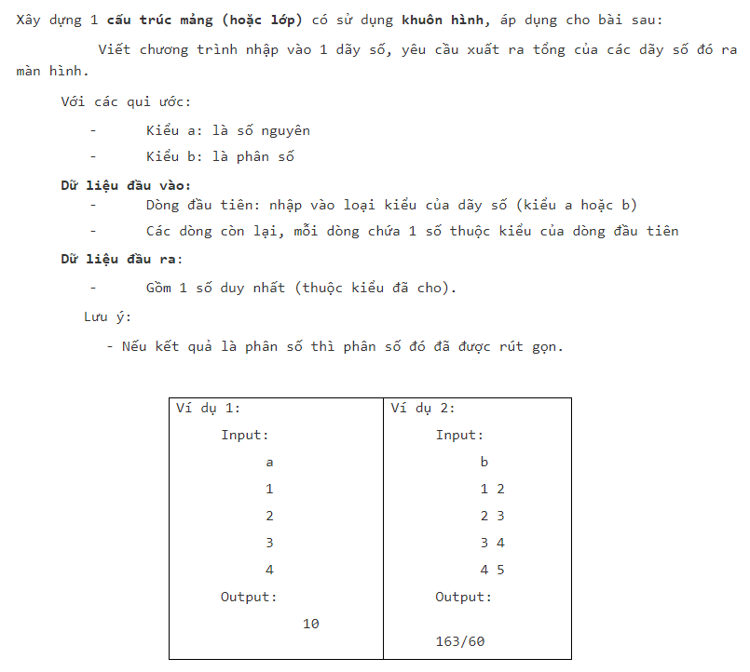

#include <bits/stdc++.h>

using namespace std;

template <typename Temp>

struct Mang {

int n;

Temp a[100];

Temp& operator[] (int i) {

return a[i];

}

Mang() {

n = 0;

}

};

struct PhanSo {

int Tu, Mau;

void operator= (PhanSo p) {

Tu = p.Tu;

Mau = p.Mau;

}

};

istream& operator>> (istream& is, PhanSo& p) {

is >> p.Tu >> p.Mau;

return is;

}

ostream& operator<< (ostream& os, PhanSo p) {

os << p.Tu << "/" << p.Mau;

return os;

}

int UCLN(int a, int b) {

while (b > 0) {

int r = a%b;

a = b;

b = r;

}

return a;

}

PhanSo rutGon(PhanSo A) {

int a = UCLN(A.Tu, A.Mau);

A.Tu /= a;

A.Mau /= a;

return A;

}

PhanSo operator+ (PhanSo A, PhanSo B) {

PhanSo Tong;

Tong.Tu = A.Tu*B.Mau + A.Mau*B.Tu;

Tong.Mau = A.Mau * B.Mau;

return rutGon(Tong);

}

template <typename Temp>

Temp tongPhanTu(Mang<Temp> mang) {

Temp Tong = mang[0];

for (int i = 1 ; i < mang.n ; i++) {

Tong = Tong + mang[i];

}

return Tong;

}

int main() {

char Type;

cin >> Type;

switch (Type) {

case 'a': {

Mang<int> mangA;

int x;

while (cin >> x) {

mangA[mangA.n++] = x;

}

cout << tongPhanTu<int>(mangA);

break;

}

case 'b': {

Mang<PhanSo> mangB;

PhanSo ps;

while (cin >> ps) {

mangB[mangB.n++] = ps;

}

cout << tongPhanTu<PhanSo>(mangB);

break;

}

}

return 0;

}

* 1. KhuonHinhSS

#include <iostream>

#include <math.h>

#include <iomanip>

using namespace std;

struct PhanSo {

int Tu, Mau;

void operator= (PhanSo p) {

Tu = p.Tu;

Mau = p.Mau;

}

PhanSo() {

Tu = 0;

Mau = 1;

}

};

istream& operator>> (istream& is, PhanSo& p) {

is >> p.Tu >> p.Mau;

return is;

}

ostream& operator<< (ostream& os, PhanSo p) {

os << p.Tu << "/" << p.Mau;

return os;

}

bool operator== (PhanSo A, PhanSo B) {

return A.Tu * B.Mau == A.Mau * B.Tu;

}

template <typename Temp>

void nhap() {

Temp a, b;

cin >> a >> b;

if (a == b)

cout << "true";

else

cout << "false";

}

int main() {

char Type;

cin >> Type;

switch (Type) {

case 'a':

nhap<int>();

break;

case 'b':

nhap<float>();

break;

case 'c':

nhap<PhanSo>();

break;

}

return 0;

}

* 1. Template1

#include <bits/stdc++.h>

using namespace std;

struct PhanSo {

int Tu, Mau;

void operator= (PhanSo p) {

Tu = p.Tu;

Mau = p.Mau;

}

};

istream& operator>> (istream& is, PhanSo& p) {

is >> p.Tu >> p.Mau;

return is;

}

ostream& operator<< (ostream& os, PhanSo p) {

os << p.Tu << "/" << p.Mau;

}

bool operator< (PhanSo A, PhanSo B) {

return double(A.Tu/A.Mau) < double(B.Tu/B.Mau);

}

template <typename Temp>

Temp Max(Temp a, Temp b, Temp c) {

Temp max = a;

if (max < b)

max = b;

if (max < c)

max = c;

return max;

}

template <typename Temp>

void nhap() {

Temp a, b, c;

cin >> a >> b >> c;

cout << Max(a, b, c);

}

int main() {

char Char;

cin >> Char;

switch (Char) {

case 'a':

nhap<int>();

break;

case 'b':

nhap<float>();

break;

case 'c':

nhap<PhanSo>();

break;

}

return 0;

}

CHƯƠNG 3: CON TRỎ

1. 1. 1718_2_LTNC_Midterm_01

Đề bài

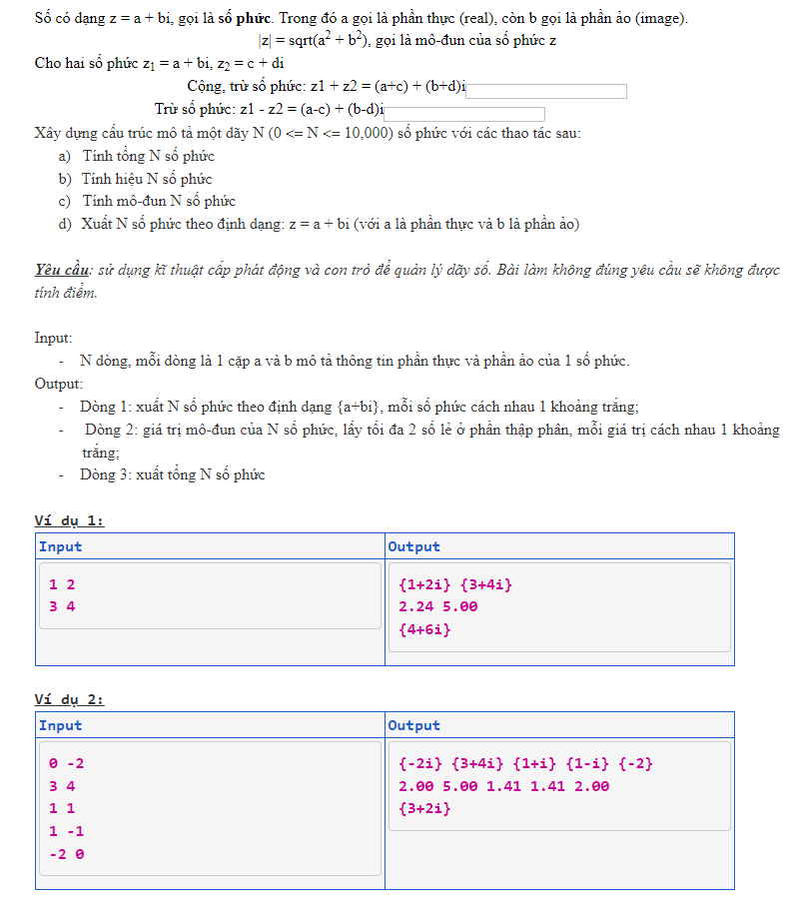

Code

#include <bits/stdc++.h>

using namespace std;

class SoPhuc {

private:

int a, b;

public:

int geta() { return a; }

void seta(int _a) { a = _a; }

int getb() { return b; }

void setb(int _b) { b = _b; }

SoPhuc(int _a = 0, int _b = 0) {

a = _a;

b = _b;

}

SoPhuc(const SoPhuc& z) {

a = z.a;

b = z.b;

}

~SoPhuc() {}

friend istream& operator>> (istream& is, SoPhuc& z) {

is >> z.a >> z.b;

return is;

}

friend ostream& operator<< (ostream& os, SoPhuc z) {

os << "{";

if (z.a != 0) {

os << z.a;

if (z.b == 1)

os << "+i}";

else {

if (z.b == -1)

os << "-i}";

else {

if (z.b < 0)

os << "-" << abs(z.b) << "i}";

if (z.b > 0)

os << "+" << abs(z.b) << "i}";

if (z.b == 0)

os << "}";

}

}

}

else {

if (z.b == 1)

os << "i}";

else {

if (z.b == -1)

os << "-i}";

else {

if (z.b < 0)

os << "-" << abs(z.b) << "i}";

if (z.b > 0)

os << abs(z.b) << "i}";

if (z.b == 0)

os << "}";

}

}

}

return os;

}

SoPhuc operator+ (SoPhuc z) {

this->a = this->a + z.a;

this->b = this->b + z.b;

return *this;

}

SoPhuc operator- (SoPhuc z) {

this->a = this->a - z.a;

this->b = this->b - z.b;

return *this;

}

float modun() {

float s = a * a + b * b;

return sqrt(s);

}

};

long n;

SoPhuc temp[100000], Tong;

SoPhuc* z;

int main() {

n = 0;

while (cin >> temp[n])

n++;

z = temp;

for (long i = 0; i < n; i++) {

cout << *(z + i) << " ";

Tong = Tong + *(z + i);

}

cout << endl;

for (int i = 0; i < n; i++) {

SoPhuc a = *(z + i);

cout << fixed << setprecision(2) << a.modun() << " ";

}

cout << endl;

cout << Tong;

return 0;

}

Testcase1

Testcase2

Testcase3

* 1. CONTRO1

Đề bài

Code

#include <bits/stdc++.h>

using namespace std;

int main() {

int n;

cin >> n;

int* a = new int[n];

for (int i = 1; i <= n; i++) {

cin >> *(a + i);

}

int* Max;

Max = a + 1;

int* Min;

Min = a + 1;

for (int i = 2; i <= n; i++) {

if (*Max < *(a + i))

Max = (a + i);

if (*Min > *(a + i))

Min = (a + i);

}

cout << *Max << endl;

for (int i = 1; i <= n; i++) {

if (*Max == *(a + i))

cout << i << " ";

}

cout << endl << *Min << endl;

for (int i = 1; i <= n; i++) {

if (*Min == *(a + i))

cout << i << " ";

}

delete[] a;

return 0;

}

Testcase1

Testcase2

Testcase3

* 1. CONTRO2

Đề bài

Code

#include <iostream>

using namespace std;

struct Node {

int data;

Node* next;

};

Node* CreateNode(int init_Data) {

Node* node = new Node;

node->data = init_Data;

node->next = NULL;

return node;

}

struct List {

Node* head;

Node* tail;

};

void CreateList(List& l) {

l.head = NULL;

l.tail = NULL;

}

void Addhead(List& l, Node* node) {

if (l.head == NULL) {

l.head = node;

l.tail = node;

}

else {

node->next = l.head;

l.head = node;

}

}

void Addtail(List& l, Node* node) {

if (l.head == NULL) {

l.head = node;

l.tail = node;

}

else {

l.tail->next = node;

l.tail = node;

}

}

void PrintList(List& l) {

if (l.head != NULL) {

Node* node = l.head;

while (node != NULL) {

cout << node->data << " ";

node = node->next;

}

}

}

int DeleteK(List& l, int k) {

int dem = 0;

Node* pp = l.head;

Node* p = l.head->next;

while (p != NULL) {

if (p->data == k) {

pp->next = p->next;

delete p;

dem++;

p = pp->next;

}

else {

pp = p;

p = p->next;

}

}

return dem;

}

int main() {

int n, k, x;

cin >> n >> k;

List l;

CreateList(l);

for (int i = 0; i < n; i++) {

cin >> x;

Addtail(l, CreateNode(x));

}

int dem = DeleteK(l, k);

if (l.head->data == k) {

Node* p = l.head;

l.head = p->next;

delete p;

dem++;

}

cout << n - dem << endl;

PrintList(l);

return 0;

}

Testcase1

Testcase2

Testcase3

* 1. CONTRO3

Đề bài

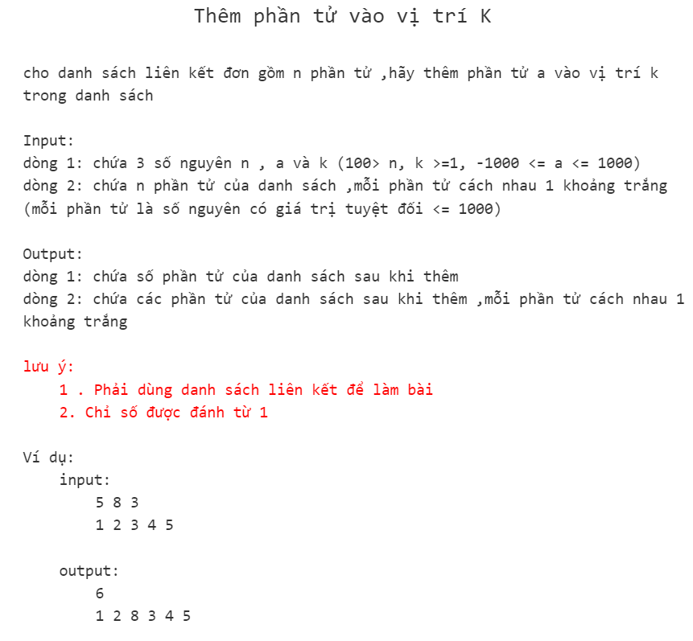

Code

#include <bits/stdc++.h>

using namespace std;

struct Node {

int data;

Node* next;

};

Node* CreateNode(int init_data) {

Node* node = new Node;

node->data = init_data;

node->next = NULL;

return node;

}

struct List {

Node* head;

Node* tail;

};

void CreateList(List& l) {

l.head = l.tail = NULL;

}

void Addhead(List& l, Node* node) {

if (l.head == NULL)

l.head = l.tail = node;

else {

node->next = l.head;

l.head = node;

}

}

void Addtail(List& l, Node* node) {

if (l.head == NULL)

l.head = l.tail = node;

else {

l.tail->next = node;

l.tail = node;

}

}

void PrintList(List& l) {

if (l.head != NULL) {

Node* node = l.head;

while (node != NULL) {

cout << node->data << " ";

node = node->next;

}

}

}

void InsertK(List& l, Node* a, int k, int& n) {

if (k == 1)

Addhead(l, a);

else {

int i = 1;

Node* node = l.head;

while (node != NULL) {

if (i == k - 1)

break;

i++;

node = node->next;

}

a->next = node->next;

node->next = a;

}

n++;

}

int main() {

int n, a, k, x;

cin >> n >> a >> k;

List l;

CreateList(l);

for (int i = 1; i <= n; i++) {

cin >> x;

Addtail(l, CreateNode(x));

}

InsertK(l, CreateNode(a), k, n);

cout << n << endl;

PrintList(l);

return 0;

}

Testcase1

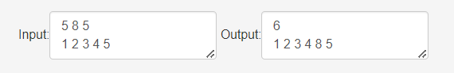

Testcase2

Testcase3

* 1. CONTRO5

Đề bài

Code

#include <bits/stdc++.h>

using namespace std;

struct Node {

int data;

Node* next;

};

Node* CreateNode(int init_data) {

Node* node = new Node;

node->data = init_data;

node->next = NULL;

return node;

}

struct List {

Node* head;

Node* tail;

List() {

head = tail = NULL;

}

};

void AddTail(List& l, Node* node) {

if (l.head == NULL)

l.head = l.tail = node;

else {

l.tail->next = node;

l.tail = node;

}

}

int main() {

int n, x;

List l;

cin >> n;

for (int i = 0; i < n; i++) {

cin >> x;

AddTail(l, CreateNode(x));

}

for (Node* p = l.head; p != NULL; p = p->next) {

for (Node* pp = l.head; pp != NULL; pp = pp->next) {

for (Node* ppp = l.head; ppp != NULL; ppp = ppp->next) {

int a = p->data;

int b = pp->data;

int c = ppp->data;

if (a != b && b != c && a != c) {

if (a == b + c) {

cout << "YES";

return 0;

}

}

}

}

}

cout << "NO";

return 0;

}

Testcase1

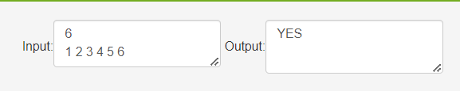

Testcase2

Testcase3

* 1. Josephus

Đề bài

Code

#include <bits/stdc++.h>

using namespace std;

struct Node {

int data;

Node* next;

};

Node* CreateNode(int init_data) {

Node* node = new Node;

node->data = init_data;

node->next = NULL;

return node;

}

struct List {

Node* head;

Node* tail;

List() {

head = tail = NULL;

}

};

void Addtail(List& l, Node* node) {

if (l.head == NULL)

l.head = l.tail = node;

else {

l.tail->next = node;

l.tail = node;

}

}

void PrintList(List& l) {

for (Node* node = l.head; node != NULL; node = node->next)

cout << node->data << " ";

}

int main() {

List l;

int N, M; cin >> N >> M;

for (int i = 1; i <= N; i++)

Addtail(l, CreateNode(i));

Node* ppp = l.head;

Node* pp = l.tail;

l.tail->next = l.head;

int dem = 0;

while (N > 0) {

dem++;

if (dem == M) {

N--;

dem = 0;

cout << ppp->data << " ";

pp->next = ppp->next;

delete ppp;

ppp = pp->next;

continue;

}

pp = ppp;

ppp = ppp->next;

}

// PrintList(l);

return 0;

}

Testcase1

Testcase2

Testcase3

* 1. Pointer_Array_01

Đề bài

Code

#include <bits/stdc++.h>

using namespace std;

int main() {

int n, j = 0, dem = 0;

cin >> n;

int* a = new int[n];

int* b = new int[n];

int* c = new int[n];

for (int i = 0; i < n; i++) {

cin >> *(a + i);

}

for (int i = n - 1; i >= 0; i--) {

*(b + j) = *(a + i);

j++;

}

n /= 2;

for (int i = 0; i < n; i++) {

if (*(b + i) != *(a + i)) {

*(c + dem) = i;

dem++;

}

}

if (dem == 0) {

cout << "mang doi xung";

}

else {

cout << "mang khong doi xung" << endl;

for (int i = 0; i < dem; i++) {

cout << *(a + *(c + i)) << " " << *(b + *(c + i)) << endl;

}

}

return 0;

}

Testcase1

Testcase2

Testcase3

* 1. Pointer_Mang_2

Đề bài

Code

#include <bits/stdc++.h>

using namespace std;

int n;

int** a;

int main() {

cin >> n;

a = new int* [n];

for (int i = 0; i < n; i++)

*(a + i) = new int[n];

for (int i = 0; i < n; i++) {

for (int j = 0; j < n; j++) {

if (i == j)

*(*(a + i) + j) = 1;

else

*(*(a + i) + j) = 0;

cout << *(*(a + i) + j) << " ";

}

cout << endl;

}

return 0;

}

Testcase1

Testcase2

Testcase3

* 1. Pointer_MissingPrime

Đề bài

Code

#include <bits/stdc++.h>

using namespace std;

int m, M;

bool* prime;

int main() {

cin >> m >> M;

prime = new bool[M];

prime[0] = prime[1] = 1;

for (int i = 2; i * i <= M; i++) {

if (!prime[i]) {

int x = i * i;

while (x <= M) {

prime[x] = 1;

x += i;

}

}

}

for (int i = m; i <= M; i++)

if (!prime[i])

cout << i << " ";

return 0;

}

Testcase1

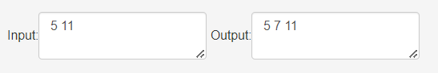

Testcase2

Testcase3

CHƯƠNG 4: VECTOR

2. 1. xoa_vector

Đề bài

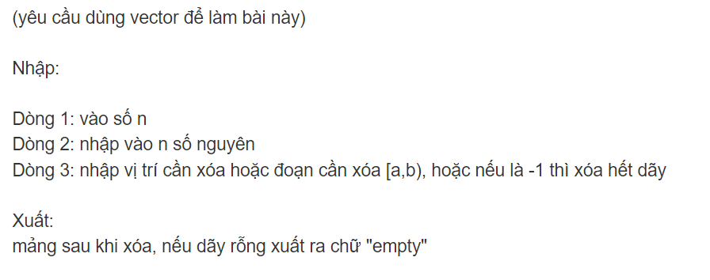

Code

#include <bits/stdc++.h>

using namespace std;

int main() {

vector<int> v, k;

int n;

cin >> n;

int x;

for (int i = 0 ; i < n ; i++) {

cin >> x;

v.push_back(x);

}

while (cin >> x)

k.push_back(x);

if (k.size() == 1)

if (k[0] == -1)

v.clear();

else {

v.erase(v.begin() + k[0]);

}

else {

v.erase(v.begin() + k[0], v.begin() + k[1]);

}

if (v.empty())

cout << "empty";

else

for (int i = 0 ; i < v.size() ; i++)

cout << v[i] << " ";

return 0;

}

Testcase1

Testcase2

Testcase3

* 1. VECTOR3

Đề bài

Code

#include <bits/stdc++.h>

using namespace std;

int main() {

vector<int> v;

int x;

while (cin >> x)

if (sqrt(x) != (int)sqrt(x))

v.push_back(x);

sort(v.begin(), v.end());

for (auto i : v)

if (i%2 == 0)

cout << i << " ";

return 0;

}

Testcase1

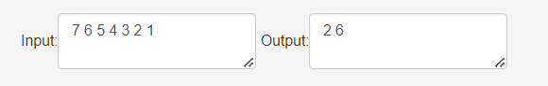

Testcase2

Testcase3

* 1. Vector

Đề bài

Code

#include <iostream>

#include <cmath>

#include <vector>

using namespace std;

bool isPrime(long n) {

if (n == 2 || n == 3)

return 1;

if (n%2 == 0)

return 0;

if (n%3 == 0)

return 0;

if (n == 1)

return 0;

for (int i = 2 ; i <= sqrt(n) ; i++) {

if (n%i == 0)

return 0;

}

return 1;

}

long sum(long n) {

long s = 0;

while (n > 0) {

if (!isPrime(n%10))

s += n%10;

n /= 10;

}

return s;

}

int main() {

int n;

long x;

vector<long> v;

cin >> n;

for (int i = 0 ; i < n ; i++) {

cin >> x;

v.push_back(x);

}

for (vector<long>::iterator it = v.begin(); it != v.end(); ++it) {

if (isPrime(*it))

cout << sum(*it);

else {

cout << -1;

}

cout << endl;

}

return 0;

}

Testcase1

Testcase2

Testcase3

* 1. Vector2

Đề bài

Code

#include <iostream>

#include <string>

#include <vector>

using namespace std;

int main() {

string s;

getline(cin, s);

int x;

vector<int> v;

while (cin >> x)

v.push_back(x);

if (s.size() == 1)

v.erase(v.begin() + (int(s[0]) - 48));

else {

if (s == "-1") {

v.clear();

cout << "empty";

return 0;

}

else {

v.erase(v.begin() + (int(s[0]) - 48), v.begin() + (int(s[2]) - 48));

}

}

for (vector<int>::iterator it = v.begin(); it != v.end(); ++it) {

cout << *it << " ";

}

return 0;

}

Testcase1

Testcase2

Testcase3

* 1. Vector1

Đề bài

Code

#include <bits/stdc++.h>

using namespace std;

int main() {

vector<int> v;

int x;

while (cin >> x)

v.push_back(x);

for (vector<int>::iterator it = v.begin() ; it != v.end() ; it++)

cout << *it << ' ';

cout << endl;

for (vector<int>::reverse_iterator it = v.rbegin() ; it != v.rend() ; it++) {

cout << *it << ' ';

}

return 0;

}

Testcase1

Testcase2

Testcase3

CHƯƠNG 5: NHẬP XUẤT FILE

5. 1. ONTAP

Đề bài

Code

#include <bits/stdc++.h>

using namespace std;

int ucln(int a, int b) {

while (b > 0) {

int r = a%b;

a = b;

b = r;

}

return a;

}

struct PhanSo {

int a, b;

PhanSo() {

a = 0;

b = 1;

}

};

void rutGon(PhanSo& p) {

int x = ucln(p.a, p.b);

p.a /= x;

p.b /= x;

}

istream& operator>> (istream& is, PhanSo& p) {

char x;

is >> p.a >> x >> p.b;

return is;

}

ostream& operator<< (ostream& os, PhanSo p) {

rutGon(p);

if (p.a == 0) {

os << 0;

return os;

}

if (p.b == 1) {

os << p.a;

return os;

}

os << p.a << "/" << p.b;

return os;

}

bool operator== (PhanSo a, PhanSo b) {

return a.a*b.b == a.b*b.a;

}

bool operator< (PhanSo a, PhanSo b) {

return a.a*b.b < a.b*b.a;

}

bool operator> (PhanSo a, PhanSo b) {

return a.a*b.b > a.b*b.a;

}

PhanSo operator+ (PhanSo a, PhanSo b) {

PhanSo c;

c.a = a.a*b.b + a.b*b.a;

c.b = a.b*b.b;

rutGon(c);

return c;

}

template <typename Temp>

struct Mang {

Temp arr[1001];

int n;

Mang() {

n = 0;

}

void operator = (Mang m){

n = m.n;

for (int i = 0; i < n; i++)

arr[i] = m.arr[i];

}

};

template <typename Temp>

istream& operator>> (istream& is, Mang<Temp>& t) {

is >> t.n;

for (int i = 0 ; i < t.n ; i++)

is >> t.arr[i];

return is;

}

template <typename Temp>

ostream& operator<< (ostream& os, Mang<Temp> t) {

for (int i = 0 ; i < t.n ; i++)

os << t.arr[i] << " ";

return os;

}

template <typename Temp>

Temp tongPhanTu (Mang<Temp> m) {

Temp t = m.arr[0];

for (int i = 1 ; i < m.n ; i++)

t = t + m.arr[i];

return t;

}

template <typename Temp>

Temp phanTuMax (Mang<Temp> m) {

Temp t = m.arr[0];

for (int i = 1 ; i < m.n ; i++)

if (t < m.arr[i])

t = m.arr[i];

return t;

}

template <typename Temp>

Mang<Temp> sapXep(Mang<Temp> m, char type = '<') {

if (type == '<') {

for (int i = 0 ; i < m.n ; i++) {

for (int j = i + 1 ; j < m.n ; j++) {

if (m.arr[i] > m.arr[j]) {

Temp t = m.arr[i];

m.arr[i] = m.arr[j];

m.arr[j] = t;

}

}

}

return m;

}

for (int i = 0 ; i < m.n ; i++) {

for (int j = i + 1 ; j < m.n ; j++) {

if (m.arr[i] < m.arr[j]) {

Temp t = m.arr[i];

m.arr[i] = m.arr[j];

m.arr[j] = t;

}

}

}

return m;

}

template <typename Temp>

Mang<Temp> operator+ (Mang<Temp> a, Mang<Temp> b) {

Mang<Temp> c;

if (a.n > b.n) {

c = a;

for (int i = 0 ; i < b.n ; i++)

c.arr[i] = c.arr[i] + b.arr[i];

return c;

}

c = b;

for (int i = 0 ; i < a.n ; i++)

c.arr[i] = c.arr[i] + a.arr[i];

return c;

}

int main() {

char value;

cin >> value;

if (value == 'I') {

Mang<int> m1, m2;

cin >> m1 >> m2;

cout << m1 << endl;

cout << "MAX 1 = " << phanTuMax(m1) << endl;

cout << "SUM 1 = " << tongPhanTu(m1) << endl;

Mang<int> m3 = sapXep(m1);

for (int i = 0 ; i < m3.n ; i++)

if (m3.arr[i]%2 == 0)

cout << m3.arr[i] << ' ';

for (int i = 0 ; i < m3.n ; i++)

if (m3.arr[i]%2 != 0)

cout << m3.arr[i] << ' ';

cout << endl << m2 << endl;

cout << "MAX 2 = " << phanTuMax(m2) << endl;

cout << "SUM 2 = " << tongPhanTu(m2) << endl;

Mang<int> m4 = sapXep(m2, '>');

for (int i = 0 ; i < m4.n ; i++)

if (m4.arr[i]%2 != 0)

cout << m4.arr[i] << ' ';

for (int i = 0 ; i < m4.n ; i++)

if (m4.arr[i]%2 == 0)

cout << m4.arr[i] << ' ';

cout << endl << m1 + m2;

return 0;

}

Mang<PhanSo> m1, m2;

cin >> m1 >> m2;

cout << m1 << endl;

cout << "MAX 1 = " << phanTuMax(m1) << endl;

cout << "SUM 1 = " << tongPhanTu(m1) << endl;

Mang<PhanSo> m3 = sapXep(m1);

cout << m3 << endl;

cout << m2 << endl;

cout << "MAX 2 = " << phanTuMax(m2) << endl;

cout << "SUM 2 = " << tongPhanTu(m2) << endl;

Mang<PhanSo> m4 = sapXep(m2, '>');

cout << m4 << endl;

cout << m1 + m2;

return 0;

}

Testcase1

Testcase2

Testcase3

* 1. FSTREAM1

Đề bài

Code

#include<iostream>

#include<fstream>

#include<math.h>

using namespace std;

int main(){

ifstream in("FSTREAM.inp");

int a;

in >> a;

ofstream out("FSTREAM.out");

if((float)sqrt(a) == (int)sqrt(a)){

out << "YES";

}else{

out << "NO";

}

in.close();

out.close();

return 0;

}

Testcase1

Testcase2

Testcase3

* 1. fstream3

Đề bài

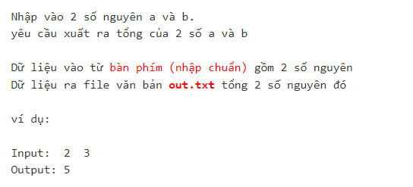

Code

#include <bits/stdc++.h>

using namespace std;

int main() {

int a, b;

cin >> a >> b;

ofstream out("out.txt");

out << a + b;

out.close();

return 0;

}

Testcase1

Testcase2

Testcase3

* 1. fstream2

Đề bài

Code

#include<iostream>

#include<fstream>

using namespace std;

int main(){

ifstream in("input.txt");

int a,b;

in >> a >> b;

ofstream out("output.txt");

out << a + b;

in.close();

out.close();

return 0;

}

Testcase1

Testcase2

Testcase3

* 1. fstream1

Đề bài

Code

#include <iostream>

#include <fstream>

using namespace std;

int main(){

ifstream in("input.txt");

int a,b;

in >> a >> b;

cout << a + b;

in.close();

return 0;

}

Testcase1

Testcase2

Testcase3

CHƯƠNG 6: STRING (CHUỖI)

6. 1. Capitalize

Đề bài

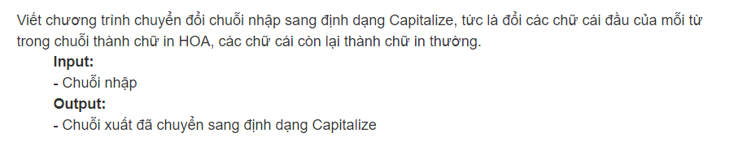

Code

#include <bits/stdc++.h>

using namespace std;

string s, token;

stringstream ss;

int main() {

getline(cin, s);

ss << s;

while (ss >> token) {

if (token[0] >= 'a' && token[0] <= 'z')

token[0] = char(int(token[0]) - 32);

for (int i = 1; i < token.size(); i++) {

if (token[i] >= 'A' && token[i] <= 'Z')

token[i] = char(int(token[i]) + 32);

}

cout << token << " ";

}

return 0;

}

Testcase1

Testcase2

Testcase3

* 1. CHUSOTANCUNG

Đề bài

Code

#include <iostream>

#include <string>

using namespace std;

int main() {

int a, n;

cin >> a >> n;

string str_a = to_string(a); // chuyển a thành chuỗi

string res = "1";

for (int i = 0; i < n; i++) {

string temp = "";

int carry = 0;

for (int j = str_a.size() - 1; j >= 0; j--) {

int num = (str_a[j] - '0') * (res[res.size() - 1] - '0') + carry;

temp = char(num % 10 + '0') + temp;

carry = num / 10;

}

if (carry > 0) {

temp = char(carry + '0') + temp;

}

res = temp;

}

cout << res[res.size() - 1] << endl; // lấy ký tự cuối cùng của chuỗi res

return 0;

}

Testcase1

Testcase2

Testcase3

* 1. DAONGUOC

Đề bài

Code

#include <iostream>

using namespace std;

int main()

{

string a;

cin >> a;

reverse(a.begin(), a.end());

cout << a;

return 0;

}

Testcase1

Testcase2

Testcase3

* 1. DAONGUOC1

Đề bài



Code

#include<iostream>

#include<string>

using namespace std;

int reverse(int a) {

int result = 0;

while (a > 0) {

result = result * 10 + a % 10;

a /= 10;

}

return result;

}

int main() {

int a[100];

int n = 0;

while(cin >> a[n++]){}

n--;

int max = a[0];

for (int i = 0; i < n; i++) {

//reverse(a[i]);

if (max < reverse(a[i])) {

max = reverse(a[i]);

}

}

cout << reverse(max);

return 0;

}

Testcase1

Testcase2

Testcase3

* 1. DAONGUOC2

Đề bài

Code

#include<iostream>

#include<string>

#include<fstream>

using namespace std;

int reverse(int a) {

int result = 0;

while (a > 0) {

result = result * 10 + a % 10;

a /= 10;

}

return result;

}

int main() {

ifstream in("inDaoNguoc2.txt");

int a[100];

int n = 0;

while (in >> a[n++]) {}

n--;

int max = a[0];

int count = 0;

int* index = new int[n];

ofstream out("outDaoNguoc2.txt");

for (int i = 0; i < n; i++) {

if (max < reverse(a[i])) {

max = reverse(a[i]);

count = 0;

index[count++] = i;

} else if(reverse(a[i]) == max)

index[count++] = i;

}

out << reverse(max) << endl;

if (count > 1) {

for (int i = 0; i < count; i++) {

out << index[i] << " ";

}

}

delete[] index;

in.close();

out.close();

return 0;

}

Testcase1

Testcase2

Testcase3

* 1. DAONGUOC3

Đề bài

Code

#include <iostream>

#include <string>

#include <algorithm>

#include <sstream>

using namespace std;

int main() {

string a;

getline(cin, a);

string b[1000];

int n = 0;

stringstream ss(a);

while(ss>>b[n++]){}

n--;

for (int i = n - 1; i >= 0; i--) {

cout << b[i] << " ";

}

}

Testcase1

Testcase2

Testcase3

* 1. DEMCHUOI

Đề bài

Code

#include<iostream>

#include<string>

using namespace std;

int main()

{

int n;

cin >> n;

cin.ignore();

string s_tim, s_nhap;

getline(cin, s_tim);

for (int i = 0; i < n; i++) {

int count = 0;

getline(cin, s_nhap);

size_t pos = 0;

while ((pos = s_nhap.find(s_tim, pos)) != string::npos) {

count++;

pos += s_nhap.find(s_tim) + 1;

}

// cout << s_tim<<endl;

// cout << s_nhap<<endl;

cout << count << endl;

}

return 0;

}

Testcase1

Testcase2

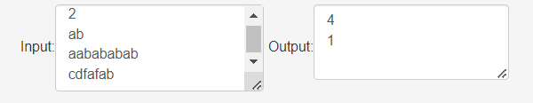

Testcase3

* 1. DOIXUNG

Đề bài

Code

#include<iostream>

#include<string>

#include<algorithm>

using namespace std;

bool is_check(string s) {

s.erase(remove(s.begin(), s.end(), ' '), s.end());

transform(s.begin(), s.end(), s.begin(), ::tolower);

/*for (int i = 0; i < s.length(); i++) {

if (s[i] == ' ') {

s.erase(s.begin() + i, s.begin() + i + 1);

}

}*/

for (int i = 0; i < (s.length() / 2); i++) {

if (s[i] != s[s.length() - i - 1]) {

return false;

}

}

return true;

}

int main()

{

int n;

cin >> n;

cin.ignore();

for (int i = 0; i < n; i++) {

string s;

getline(cin, s);

cout << is_check(s)<<endl;

}

return 0;

}

Testcase1

Testcase2

Testcase3

* 1. DATE

Đề bài

Code

#include <iostream>

#include <string>

using namespace std;

struct Date

{

int month, day, year;

};

istream& operator>>(istream& inp, Date& d)

{

inp >> d.day >> d.month >> d.year;

return inp;

}

ostream& operator<<(ostream& out, Date d)

{

if (d.day < 10) out << 0 << d.day;

else out << d.day;

out << "/";

if (d.month < 10) out << 0 << d.month;

else out << d.month;

out << "/";

out << d.year;

return out;

}

bool LeapYear(Date d)

{

return (d.year % 4 == 0 && d.year % 100 != 0) || (d.year % 400 == 0);

}

int ndayofYear(Date d)

{

int x = 0, i;

for (i = 1; i < d.month; i++)

{

switch (i)

{

case 1: case 3: case 5: case 7: case 8: case 10: case 12:

{

x += 31;

break;

}

case 4: case 6: case 9: case 11:

{

x += 30;

break;

}

case 2:

{

if (LeapYear(d))

{

x += 29;

}

else

{

x += 28;

}

break;

}

}

}

return x + d.day;

}

string ndayofWeek(Date d)

{

string s;

int n = d.year;

int c = ndayofYear(d);

int t1 = (n - 1) / 4;

int t2 = (n - 1) / 100;

int t3 = (n - 1) / 400;

int k = (n - 1) + t1 - t2 + t3 + c;

switch (k % 7)

{

case 0:

{

s = "Sunday";

break;

}

case 1:

{

s = "Monday";

break;

}

case 2:

{

s = "Tuesday";

break;

}

case 3:

{

s = "Wednesday";

break;

}

case 4:

{

s = "Thursday";

break;

}

case 5:

{

s = "Friday";

break;

}

case 6:

{

s = "Saturday";

break;

}

}

return s;

}

int ndayofMonth(Date d)

{

int nday;

switch (d.month)

{

case 1: case 3: case 5: case 7: case 8: case 10: case 12:

{

nday = 31;

break;

}

case 4: case 6: case 9: case 11:

{

nday = 30;

break;

}

case 2:

{

if (LeapYear(d))

{

nday = 29;

}

else

{

nday = 28;

}

break;

}

}

return nday;

}

Date nextDay(Date d)

{

Date nextd;

if (d.day == ndayofMonth(d))

{

if (d.month == 12)

{

nextd.day = 1;

nextd.month = 1;

nextd.year = d.year + 1;

}

else

{

nextd.day = 1;

nextd.month = d.month + 1;

nextd.year = d.year;

}

}

else

{

nextd.day = d.day + 1;

nextd.month = d.month;

nextd.year = d.year;

}

return nextd;

}

bool operator==(Date d1, Date d2)

{

return d1.day == d2.day && d1.month == d2.month && d1.year == d2.year;

}

void likendayofWeek(Date d1, Date d2)

{

ndayofWeek(d1) == ndayofWeek(d2) ? cout << "TRUE" : cout << "FALSE";

}

bool operator<(Date d1, Date d2)

{

if (d1.year < d2.year)

{

return true;

}

else if (d1.year == d2.year)

{

if (d1.month < d2.month)

{

return true;

}

else if (d1.month == d2.month)

{

if (d1.day < d2.day) return true;

else return false;

}

else return false;

}

else return false;

}

int operator-(Date d1, Date d2)

{

int y;

if (d1.year == d2.year)

{

if (d1 < d2)

{

return ndayofYear(d2) - ndayofYear(d1);

}

else if (d1 == d2) return 0;

else

{

return ndayofYear(d1) - ndayofYear(d2);

}

}

if (d1.year < d2.year)

{

if (LeapYear(d1))

{

y = 366 - ndayofYear(d1);

}

else y = 365 - ndayofYear(d1);

for (int i = d1.year + 1; i < d2.year; i++)

{

if ((i % 4 == 0 && i % 100 != 0) || (i % 400 == 0))

{

y += 366;

}

else y += 365;

}

return y + ndayofYear(d2);

}

if (d1.year > d2.year)

{

if (LeapYear(d2))

{

y = 366 - ndayofYear(d2);

}

else y = 365 - ndayofYear(d2);

for (int i = d2.year + 1; i < d1.year; i++)

{

if ((i % 4 == 0 && i % 100 != 0) || (i % 400 == 0))

{

y += 366;

}

else y += 365;

}

return y + ndayofYear(d1);

}

}

int main()

{

Date x1, x2;

cin >> x1;

cin >> x2;

cout << x1 << " " << ndayofWeek(x1) << " " << ndayofYear(x1) << " " << nextDay(x1) << " ";

LeapYear(x1) == true ? cout << "TRUE" : cout << "FALSE";

cout << endl;

cout << x2 << " " << ndayofWeek(x2) << " " << ndayofYear(x2) << " " << nextDay(x2) << " ";

LeapYear(x2) == true ? cout << "TRUE" : cout << "FALSE";

cout << endl;

likendayofWeek(x1, x2);

cout << endl;

if (x1 < x2) cout << "1 < 2";

else if (x1 == x2) cout << "1 = 2";

else cout << "1 > 2";

cout << endl;

cout << x1 - x2;

}

Testcase1

Testcase2

Testcase3

* 1. DAYNP

Đề bài

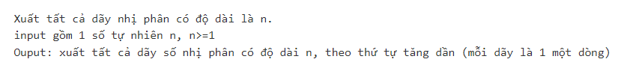

Code

#include <iostream>

#include <string>

#include <math.h>

using namespace std;

string sinhNhiPhan(int so, int doDai)

{

string res = "";

int phanDu;

while(so > 0)

{

phanDu = so % 2;

res = (char)(phanDu + '0') + res;

so /= 2;

}

while(res.size() < doDai)

{

res = '0' + res;

}

return res;

}

void sinhNhiPhanTiepTheo(string& s)

{

int pos = -1;

for(int i = s.size() - 1; i >= 0; i--)

{

if(s[i] == '0')

{

pos = i;

break;

}

}

if(pos == -1) return;

s[pos] = '1';

for(int i = pos + 1; i < s.size(); i++) s[i] = '0';

return;

}

int main()

{

int n;

cin >> n;

int soLuong = pow(2, n);

int cach = 2;

string s = "0";

while(s.size() < n) s += '0';

for(int i = 0; i < soLuong; i++)

{

if(cach == 1)cout << sinhNhiPhan(i, n) << endl;

else

{

cout << s << endl;

sinhNhiPhanTiepTheo(s);

}

}

return 0;

}

Testcase1

Testcase2

Testcase3

* 1. SoPalindrom

Đề bài

Code

#include <iostream>

using namespace std;

int reverse(int a) {

int result = 0;

while (a > 0) {

result = result * 10 + a % 10;

a /= 10;

}

return result;

}

int main()

{

int n;

int a[1000];

cin >> n;

for (int i = 0; i < n; i++) {

cin >> a[i];

}

for (int i = 0; i < n; i++) {

if (reverse(a[i]) == a[i]) {

cout << a[i] << " ";

}

}

return 0;

}

Testcase1

Testcase2

Testcase3

* 1. HAPPYNEWYEAR

Đề bài

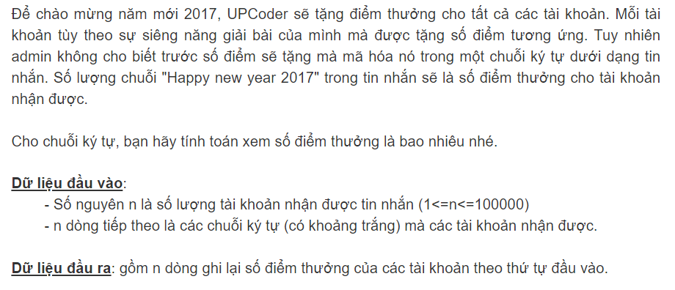

Code

#include <iostream>

#include <string>

using namespace std;

string s;

int n, t, dem;

int main() {

cin >> n;

cin.ignore();

while (n > 0) {

getline(cin, s);

dem = 0;

t = s.find("Happy new year 2017");

while (t != -1) {

dem++;

t = s.find("Happy new year 2017", t + 1);

}

cout << dem;

if (n > 1)

cout << endl;

n--;

}

return 0;

}

Testcase1

Testcase2

Testcase3

* 1. Hpalindrome

Đề bài

Code

#include<iostream>

#include<fstream>

#include<string>

#include<algorithm>

using namespace std;

bool check(string s) {

s.erase(remove(s.begin(), s.end(), ' '), s.end());

transform(s.begin(), s.end(), s.begin(), ::tolower);

int m = s.length();

for (int i = 0; i < m / 2; i++) {

if (s[i] != s[m - i - 1]) {

return false;

}

}

return true;

}

int main()

{

ifstream in("input.txt");

ofstream out("output.txt");

string s;

while (getline(in, s)) {

if (check(s)) {

out << "1" << endl;

}

else

out << "0" << endl;

}

in.close();

out.close();

return 0;

}

Testcase1

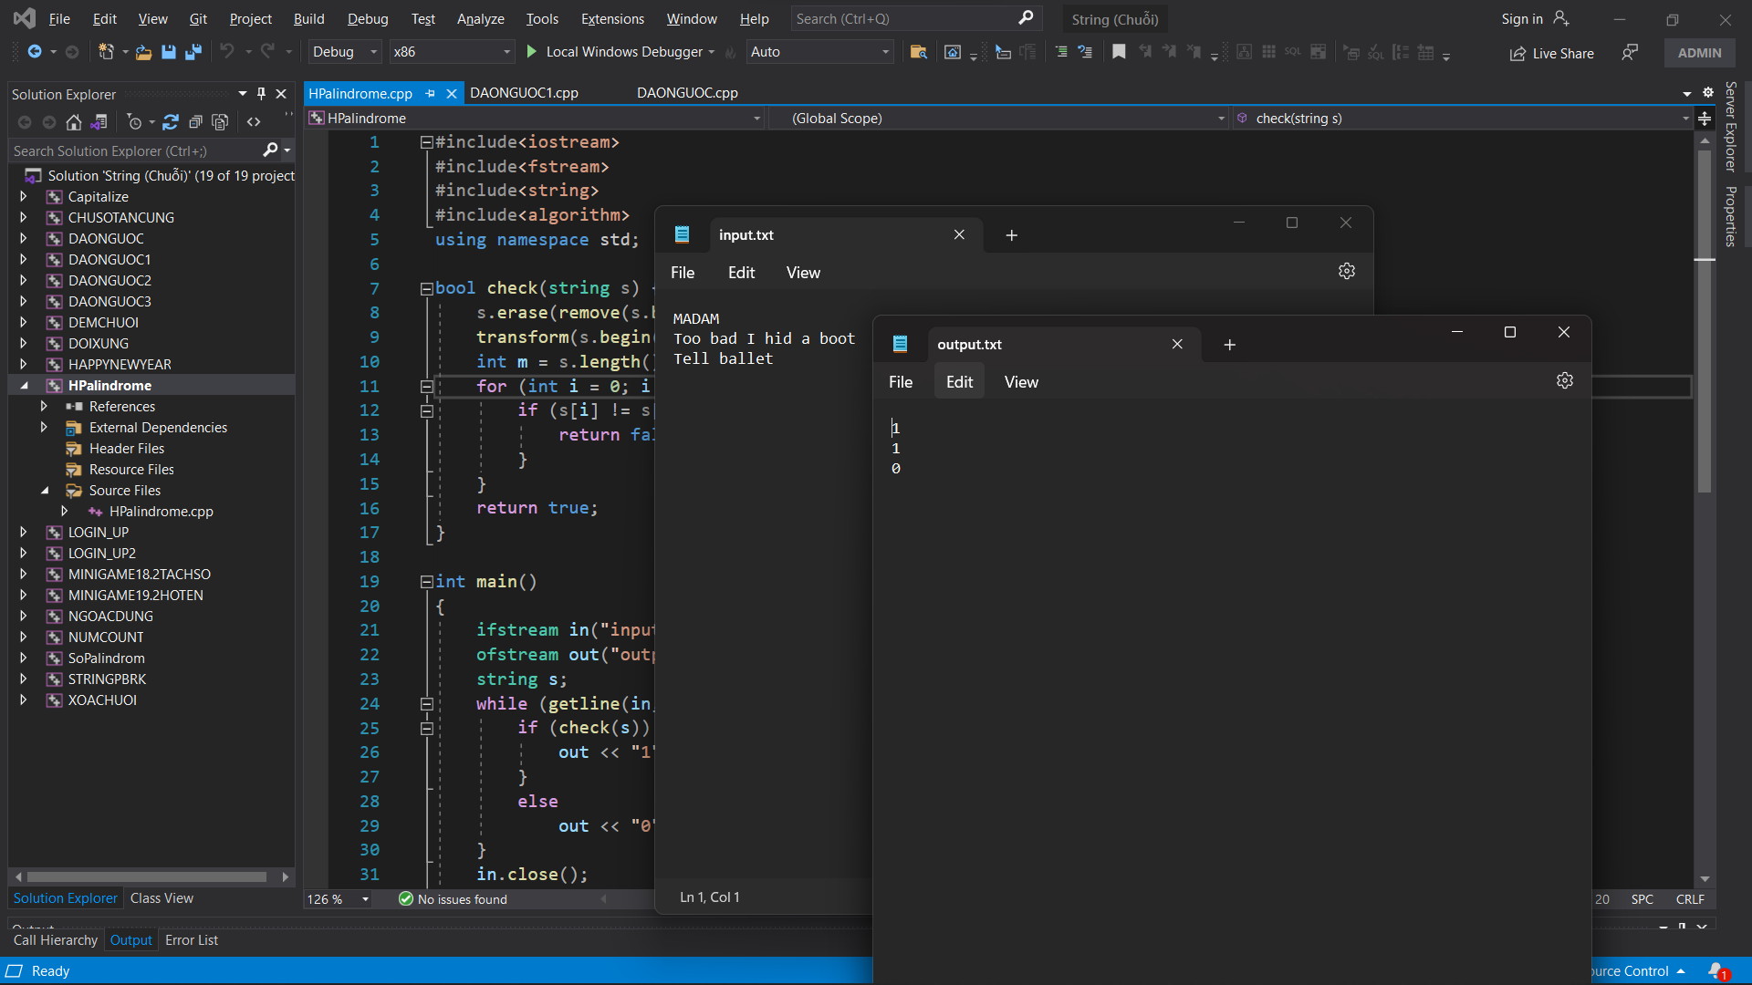

* 1. NUMCOUNT

Đề bài

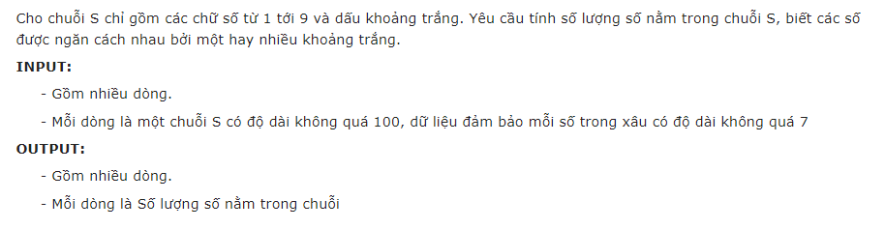

Code

#include <iostream>

#include<string>

using namespace std;

void demso(string& s)

{

int dem = 0;

for (int i = 0; i < s.length(); i++)

{

if (s[i] != ' ' && s[i + 1] == ' ')

{

dem++;

}

}

if (s.size() - 1 != ' ')

{

dem++;

}

cout << dem << "\n";

}

int main()

{

string s;

while (getline(cin, s))

{

demso(s);

}

return 0;

}

Testcase1

Testcase2

Testcase3

* 1. MINIGAME19.2HOTEN

Đề bài

Code

#include <iostream>

#include <string>

using namespace std;

void hoTen(string s[], int i) {

cout << "Ho: " << s[0] << endl;

if (i > 2) {

cout << "Lot: ";

for (int j = 1; j < i - 1; j++)

cout << s[j] << " ";

cout << endl;

}

cout << "Ten: " << s[i - 1];

}

int main() {

string s[50];

int i = 0;

while (cin >> s[i])

i++;

hoTen(s, i);

return 0;

}

Testcase1

Testcase2

Testcase3

* 1. MINIGAME18.2TACHSO

Đề bài

Code

#include <sstream>

#include <vector>

#include <iostream>

#include <fstream>

using namespace std;

vector<int> toInt(string str) {

vector<int> v;

stringstream ss;

string tmp = "";

int x;

for (int i = 0; i < str.size(); i++) {

if (str[i] != ',')

tmp = tmp + str[i];

if (str[i] == ',' || i == str.size() - 1) {

//xuat ra cac chu so

ss << tmp;

ss >> x;

v.push_back(x);

ss.clear();

tmp = "";

}

}

return v;

}

int main() {

string str;

cin >> str;

vector<int> v = toInt(str);

long long sum = 0;

for (int i = 0; i < v.size(); i++) {

cout << v[i] << endl;

sum += v[i];

}

cout << sum << endl;

return 0;

}

Testcase1

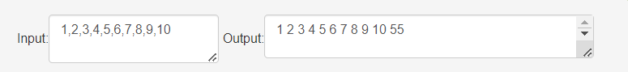

Testcase2

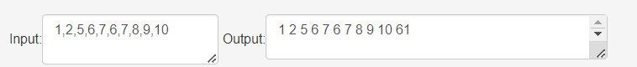

Testcase3

* 1. LOGIN_UP

Đề bài

Code

#include <bits/stdc++.h>

using namespace std;

int main() {

char a;

int i = 0, dem = 0;

string s = "upcoder";

while (cin >> a) {

if (a == s[i]) {

i++;

dem++;

}

}

if (dem == 7)

cout << "YES";

else

cout << "NO";

return 0;

}

Testcase1

Testcase2

Testcase3

* 1. LOGIN_UP2

Đề bài

Code

#include <iostream>

#include <cstring>

#include <stdio.h>

using namespace std;

char a[501][101], demo[] = "upcoder";

int n, m = 0, dd[501];

int check(char a[])

{

int j = 0;

for (int i = 0; i < strlen(a); i++)

if (a[i] == demo[j])

{

j++;

if (j == 7)

return 1;

}

return 0;

}

int main()

{

cin >> n;

for (int i = 0; i < n; i++)

{

cin >> a[i];

dd[i] = 0;

}

for (int i = 0; i < n; i++)

if (check(a[i]))

{

dd[i] = 1;

m++;

}

cout << m << endl;

for (int i = 0; i < n; i++)

if (dd[i])

cout << i + 1 << " ";

return 0;

}

Testcase1

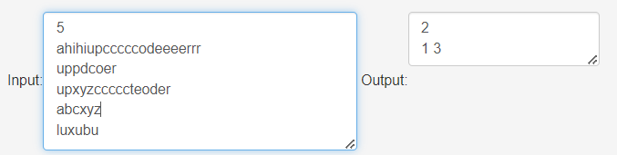

Testcase2

* 1. STRINGPBRK

Đề bài

Code

#include <iostream>

#include <string>

using namespace std;

bool Chars(string s) {

// Kiểm tra xem từ s có chứa ký tự b, d, f, h, k, t hay không.

for (int i = 0; i < s.length(); i++) {

if (s[i] == 'b' || s[i] == 'd' || s[i] == 'f' || s[i] == 'h' || s[i] == 'k' || s[i] == 't') {

return true;

}

}

return false;

}

int main() {

string s, longest = "";

while (cin >> s) {

string word = "";

for (int i = 0; i < s.length(); i++) {

if (s[i] != ' ') {

word += s[i];

}

else {

// Kiểm tra từ hiện tại

if (!Chars(word)) {

// Nếu từ hiện tại không chứa ký tự b, d, f, h, k, t

if (word.length() > longest.length()) {

// Nếu từ hiện tại dài hơn từ dài nhất hiện tại

longest = word;

}

}

word = "";

}

}

// Kiểm tra từ cuối cùng trong chuỗi

if (!Chars(word)) {

if (word.length() > longest.length()) {

longest = word;

}

}

}

cout << longest << endl;

return 0;

}

Testcase1

Testcase2

Testcase3

* 1. XOACHUOI

Đề bài

Code

#include<iostream>

#include<string>

using namespace std;

int main()

{

string X, Y;

getline(cin, X);

getline(cin, Y);

//X.erase(remove(X.begin(), X.end(), ' '), X.end());

//Y.erase(remove(Y.begin(), Y.end(), ' '), Y.end());

int i = 0, j = 0, count = 0;

while (i < X.length() && j < Y.length()) {

if (X[i] == Y[j]) {

i++;

j++;

}

else {

j++;

count++;

}

}

if (i == X.length()) {

cout << "YES" << endl;

cout << count << endl;

}

else {

cout << "NO" << endl;

}

return 0;

}

Testcase1

Testcase2

Testcase3

* 1. 1718_2_LTNC_Midterm_02

Đề bài

Code

#include <iostream>

#include <algorithm>

#include <string>

using namespace std;

int main() {

string s1, s2;

cin >> s1 >> s2;

// Kiểm tra độ dài của hai chuỗi

if (s1.length() != s2.length()) {

cout << "NO" << endl;

} else {

// Sắp xếp các ký tự trong hai chuỗi

sort(s1.begin(), s1.end());

sort(s2.begin(), s2.end());

// So sánh hai chuỗi đã sắp xếp

if (s1 == s2) {

cout << "YES" << endl;

} else {

cout << "NO" << endl;

}

}

return 0;

}

Testcase1

Testcase2

Testcase3

CHƯƠNG 7: STACK VÀ QUEUE

1. 1. PALINDROME_STRING

Đề bài

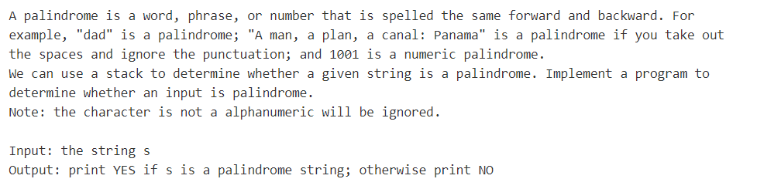

Code

#include <bits/stdc++.h>

using namespace std;

string s, x = "";

string t;

int main() {

getline(cin, s);

for (int i = 0 ; i < s.size() ; i++) {

s[i] = tolower(s[i]);

if ((s[i] >= 'a' && s[i] <= 'z') || (s[i] >= '0' && s[i] <= '9'))

x += s[i];

}

t = x;

reverse(t.begin(), t.end());

if (t == x)

cout << "YES";

else

cout << "NO";

return 0;

}

Testcase1

Testcase2

Testcase3

* 1. TRUNGHAUTO2

Đề bài

Code

#include <bits/stdc++.h>

using namespace std;

int prior(string x) {

if (x == "+" || x == "-")

return 1;

if (x == "*" || x == "/" || x == "%" || x == "^")

return 2;

}

int main() {

stack<string> st;

string s;

while (cin >> s) {

if (s >= "0" && s <= "9")

cout << s << " ";

else if (s == "(")

st.push(s);

else if (s == ")") {

while (st.top() != "(") {

cout << st.top() << " ";

st.pop();

}

if (st.top() == "(")

st.pop();

}

else {

while (!st.empty() && st.top() != "(" && prior(st.top()) >= prior(s)) {

cout << st.top() << " ";

st.pop();

}

st.push(s);

}

}

while (!st.empty()) {

cout << st.top() << " ";

st.pop();

}

return 0;

}

Testcase1

Testcase2

Testcase3

* 1. TRUNGHAUTO1

Đề bài

Code

#include <bits/stdc++.h>

using namespace std;

struct Stack{};

void init();

void push(Stack &st, int x);

int top(Stack st);

void pop(Stack &st);

bool empty(Stack st);

bool full(Stack st);

int prior(char x) {

return (x == '+' || x == '-') ? 1 :

(x == '*' || x == '/' || x == '%') ? 2 : 0;

}

string s;

stack<char> st;

int main() {

cin >> s;

for (int i = 0 ; i < s.size() ; i++) {

if (isdigit(s[i]))

cout << s[i] << " ";

else if (s[i] == '+' || s[i] == '-' || s[i] == '*' || s[i] == '/' || s[i] == '%') {

while (!st.empty() && st.top() != '(' && prior(st.top()) >= prior(s[i])) {

cout << st.top() << " ";

st.pop();

}

st.push(s[i]);

}

else if (s[i] == '(')

st.push(s[i]);

else {

while (st.top() != '(') {

cout << st.top() << " ";

st.pop();

}

if (st.top() == '(')

st.pop();

}

}

while (!st.empty()) {

cout << st.top() << " ";

st.pop();

}

return 0;

}

Testcase1

Testcase2

Testcase3

* 1. QUEUE1

Đề bài

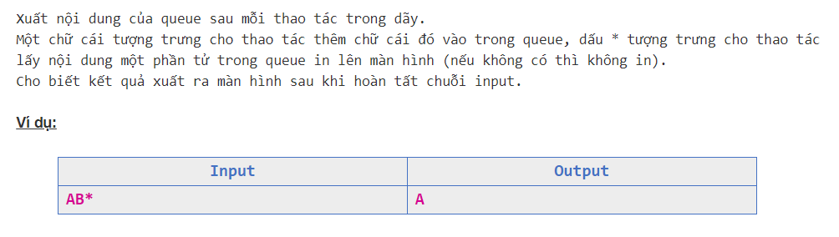

Code

#include <bits/stdc++.h>

using namespace std;

queue<char> q;

char x;

int main() {

while (cin >> x) {

if (x == '*') {

if (!q.empty()) {

cout << q.front();

q.pop();

}

}

else

q.push(x);

}

return 0;

}

Testcase1

Testcase2

Testcase3

* 1. TT_HT1

Đề bài

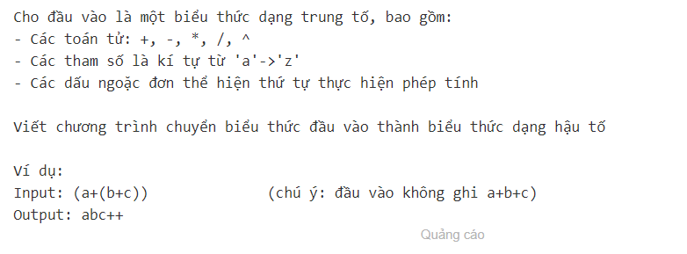

Code

#include <bits/stdc++.h>

std::string s;

std::stack<char> st;

int prior(char x) {

return (x == '+' || x == '-') ? 1

: (x == '*' || x == '/' || x == '^') ? 2 : 0;

}

int main() {

std::cin >> s;

for (int i = 0 ; i < s.size() ; i++) {

if (s[i] >= 'a' && s[i] <= 'z')

std::cout << s[i];

else if (s[i] == '(')

st.push(s[i]);

else if (s[i] == '+' || s[i] == '-' || s[i] == '*'

|| s[i] == '/' || s[i] == '%' || s[i] == '^') {

while (!st.empty() && st.top() != '(' && prior(st.top()) >= prior(s[i])) {

std::cout << st.top();

st.pop();

}

st.push(s[i]);

}

else {

while (st.top() != '(') {

std::cout << st.top();

st.pop();

}

if (st.top() == '(')

st.pop();

}

}

while (!st.empty()) {

std::cout << st.top();

st.pop();

}

return 0;

}

Testcase1

Testcase2

Testcase3

* 1. DOICS10_2

Đề bài

Code

#include <bits/stdc++.h>

using namespace std;

int n;

stack<int> s;

int main() {

cin >> n;

if (n == 0) {

cout << 0;

return 0;

}

while (n > 0) {

s.push(n%2);

n = n/2;

}

while (!s.empty()) {

cout << s.top();

s.pop();

}

return 0;

}

Testcase1

Testcase2

Testcase3

* 1. HAUTO

Đề bài

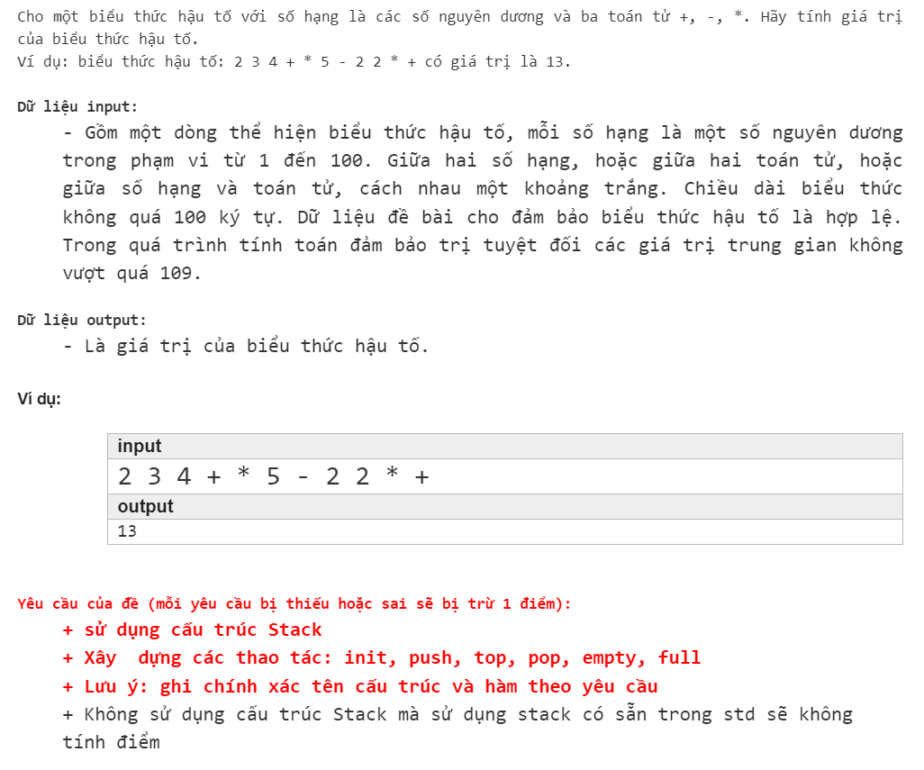

Code

#include <bits/stdc++.h>

using namespace std;

int Stack();

int init ();

int top();

int pop();

int empty();

int full();

string s;

stack<int> st;

int main() {

while (cin >> s) {

if (s == "+" || s == "-" || s == "*") {

if (!st.empty()) {

int b = st.top(); st.pop();

int a = st.top(); st.pop();

if (s == "+") st.push(a + b);

if (s == "-") st.push(a - b);

if (s == "*") st.push(a * b);

}

}

else st.push(stoi(s));

}

cout << st.top();

return 0;

}

Testcase1

Testcase2

Testcase3

* 1. STACK1

Đề bài

Code

#include <bits/stdc++.h>

using namespace std;

int main() {

string s;

stack<char> st;

cin >> s;

for (int i = 0 ; i < s.size() ; i++) {

if ((s[i] >= 'A' && s[i] <= 'Z') || (s[i] >= 'a' && s[i] <= 'z'))

st.push(s[i]);

if (s[i] == '*') {

if (!st.empty()) {

cout << st.top();

st.pop();

}

}

}

return 0;

}

Testcase1

Testcase2

Testcase3

* 1. NGOACDUNG

Đề bài

Code

#include <bits/stdc++.h>

using namespace std;

int main() {

stack<char> st;

char x;

while (cin >> x) {

if (x == '[' || x == '(' || x == '{')

st.push(x);

else {

if (!st.empty()) {

if (x == ']' && st.top() == '[')

st.pop();

else if (x == ')' && st.top() == '(')

st.pop();

else if (x == '}' && st.top() == '{')

st.pop();

}

else

st.push(x);

}

}

if (st.empty())

cout << "yes";

else

cout << "no";

return 0;

}

Testcase1

Testcase2

Testcase3

